ST. WILFRID’S RC COLLEGE
PUPIL PREMIUM

Background
The pupil premium was introduced in April 2011 and is additional funding to main school funding given to schools to raise the attainment of disadvantaged pupils and close the gap between them and their peers. The Government has used pupils entitled to Free School Meals as an indicator for deprivation and the funding helps to tackle those inequalities of the pupils who need it most.
The pupil premium was allocated to St. Wilfrid’s RC College for pupils who have either registered for free schools meals at any point with the last six years, children who have been on the Local Authority’s looked after children register, and children of service personnel. As an example, St. Wilfrid’s College has 28.9% (source: Raiseonline 2013) pupils eligible for Free School Meals.
The pupil premium is paid to schools as the Government believes they are best placed to assess what additional provision their pupils need.
Use of Pupil Premium in 2013-14
In 2013-14 St. Wilfrid’s received £206,100, with an additional £11,700, part through the year (£217,800). The intervention strategies of the school supported the use of Pupil Premium funding, which allowed our students to benefit from the following:
- Homework club after school everyday
- One to one reading sessions
- Support to pupils and their families from SEN co-ordinator
- Pastoral liaison Officer
- Support from the deployment and integration of teaching assistants
- Learning mentor to support academic strategies
- Chaplaincy services including support groups
- Study support
- Support to Enhance Progress (STEP) small group sessions after school by subject specialists
- Reading club
- Planning for pupil progress and stretch and challenge
- Breakfast club
- Breakfast before exams and water during exams
- Family learning opportunities
- Subsidised music tuition
- Subsidised extra-curricular activities

Impact
In excess of 200 STEP (Support to Enhance Progress) sessions have taken place after school. There have been approximately 800 individual attendances by PP pupils at these sessions during 2013-14.
The following table shows that the attainment gap between Pupil Premium students and Non Pupil Premium students has narrowed in almost all areas between 2013 and 2014.
The intervention and strategies listed above are all key in ensuring that this positive performance continues.
Gap Analysis: GCSE 2014 Comparison between Pupil Premium and Non-Pupil Premium results
KS 4 Attainment | All Pupils | Pupil Premium | Non Pupil Premium | Gap  2014 | Gap  2013
% 5A*C EM | 66 | 57.8 | 69.5 | -11.7 | -20
APS Capped 8 | 334 | 308 | 343 | -35 | -37
% A*-G | 100 | 100 | 100 | 0 | -1
% A*-C English | 87.5 | 84.4 | 89.3 | -4.9 | -5.2
% A*-C Maths | 78.4 | 73.3 | 80.2 | -6.9 | -8
% 2x(A*-C) Science | 76 | 71 | 77 | -6 | -24
% A*-A English | 23 | 9 | 27 | -18 | -24
% A*-A Maths | 22 | 16 | 24 | -8 | -27
APS English | 44 | 41.6 | 44.8 | -3.2 | -4.5
APS Maths | 40.9 | 39.5 | 41.5 | -2.0 | -5.5
% achieving EBacc | 40.3 | 20.0 | 47.3 | -27.3 | -28.5

Progress | All Pupils | Pupil Premium | Non Pupil Premium | Gap  2014 | Gap  2013
% 3+ levels English | 91 | 90.9 | 91.4 | -0.5 | -7
% 4+ levels English | 45 | 34 | 49 | -15 | -15
% 3+ levels English | 75 | 72.1 | 76.6 | -4.5 | -14
% 4+ levels English | 28 | 21 | 30 | -9 | -29

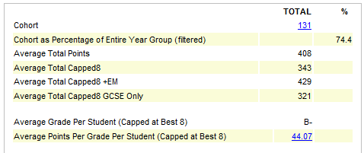
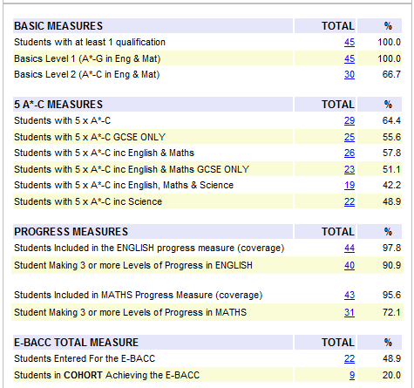
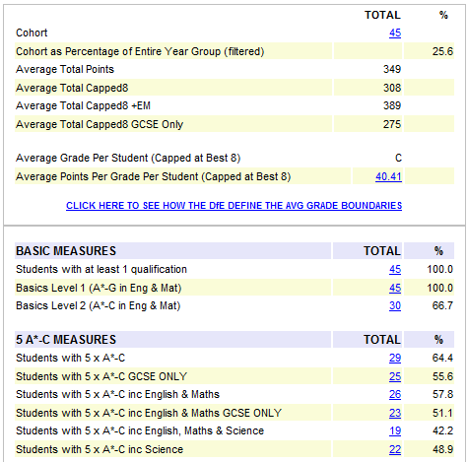
Relative performance: FSM (PP) v Non – FSM (PP) GCSE 2014
Non - FSM (PP)
FSM (PP)

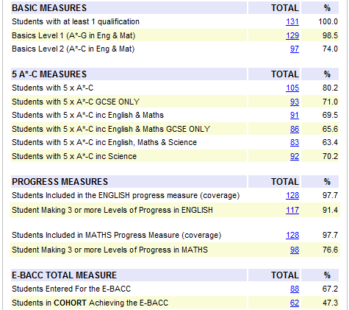

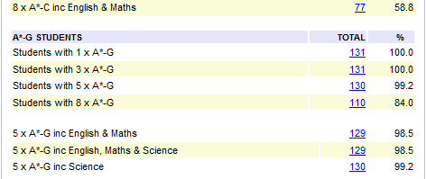
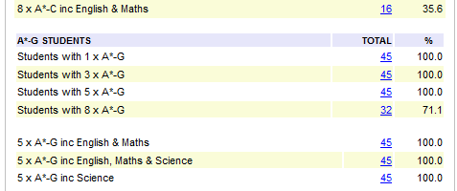
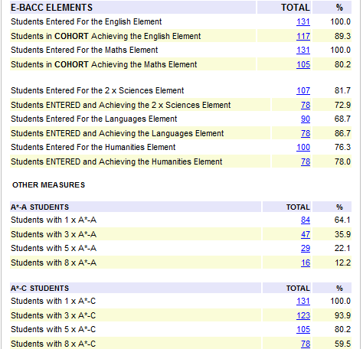
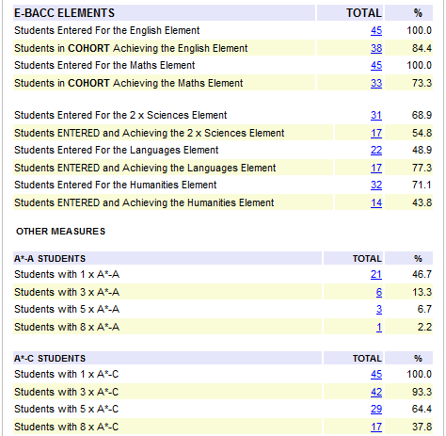
Non - FSM (PP)
FSM (PP)

Pupil Premium 2014-15
The pupil premium funding for St. Wilfrid’s has increased in the academic year 2014-15 to £227,295. This funding has enabled the school to continue to provide the following, and offer additional strategies:
Provision | Approx costs | Support for learners
Homework Club KS3/KS4 | £2,000 | Small group sessions every night after school, to assist all pupils with homework issues and support. This is open to all pupils as well as pupils who are targeted for extra support with homework.
SEND Services | £160,000 | Provides support to pupils and their families. Some of the most vulnerable and disadvantaged pupils fit into this category.  Teaching Assistants are deployed in many different ways to support our children who may require one to one support to achieve their potential.
Pastoral Liaison | £26,000 | Provides support for pastoral team in linking in with hard to reach parents and families. Builds relationships with families and is able to respond quickly if required to.
School Chaplaincy Services | £22,000 | One to one intervention with pupils who require low level support. Runs and organises bereavement group, Hosts young carers meetings fortnightly. Organises class masses and whole school liturgy as well as year group retreats. Is responsible for development of school ethos in liaison with head of RE and SLT.
Study Support (Intervention)  STEP (Support to Enhance Progress)  Reading Club  One to one Reading  Planning for Pupil Progress | £20,000 | Subject specific study session timetabled throughout the year for every subject, with specialists allowing targeted pupils access to support at key times of need. This involves after school STEP session, holiday sessions, study breakfasts before exams and one to one assistance. Many voluntary sessions have also been well attended.
Subsidised Music Tuition | £10,000 | Increase involvement in extra-curricular music and drama across the school. We have the highest number of pupils in the authority involved in peripatetic music in the authority. This raises pupils’ confidence and aspirations.
Careers Guidance | £10,000 | CEIAG support for all students Y7-Y13 to ensure they are best placed to progress into the education or employment pathway of their choice. Additional expertise and high quality delivery of post 16 careers and FE guidance from representatives from Rising Star.
Pastoral Mentors | £9,000 | Offer one to one support to yrs 7 – 11 pupils, around organisation, aspirations and subject issues. Mentors monitor targeted pupil progress and ensure they are fully supported in reaching their potential.
Teaching & Learning Mentors | £7,000 | Teaching and Learning team to improve the quality of specific learning support for individual pupil needs through whole staff training and through provision of CPD programmes within school.
Total | £266,000

