NORTHERN SAINTS CATHOLIC EDUCATION TRUST

St Wilfrid’s RC College Complaints Policy
Procedure on the Handling of Concerns and Complaints

This policy applies to all concerns and complaints other than

- Child Protection issues and
- Exclusions where separate procedures apply.

This policy complies with Schedule 1, Part 7 of the Education (Independent School Standards) (England) Regulations 2010.

Timescales:
We aim to resolve any complaints in a timely manner. Timescales for each stage of the Complaints Procedure are set out below in the relevant paragraphs. For the purposes of this policy, a "working day" is defined as a weekday during term time, when the academy is open. The definition of "working day" excludes weekends and Bank Holidays.

Policy Aim and Statement

Aim:
The aim of this policy is to ensure that a concern or complaint by a parent/carer is managed sympathetically, efficiently and at the appropriate level and resolved as soon as possible. Doing so is good practice, it is fair to those concerned and it helps to promote parents’ and students’ confidence in our ability to safeguard and promote welfare. We will try to resolve every concern or complaint in a positive way with the aim of resolving the issue in a transparent manner.

The academy expects that most concerns can be resolved informally and guarantees to treat seriously and confidentially all concerns whether raised informally or formally.

Statement:
We need to know as soon as possible if there is any cause for dissatisfaction. We recognise that a difficulty that is not resolved quickly and fairly can soon become a cause of resentment, which could be damaging to relationships and also to our academy culture. We intend that parents and students should never feel – or be made to feel – that a complaint will be taken amiss or will adversely affect a student or his/her opportunities at the academy. The policy, however, distinguishes between a concern or difficulty which can be resolved informally and a formal complaint which will require further investigation.

Our aim is to resolve all concerns at the lowest possible level.

Stage 1: Informal Complaints

1. Concerns: Most concerns, where a parent/carer seeks intervention, reconsideration or some other action to be taken, can be resolved informally. Examples might include dissatisfaction about some aspect of teaching, disciplinary matters or issues outside the classroom.

Parents/carers should raise the concern initially with the Head of House/Head of Year (Sixth Form) a member of the Senior Leadership Team (SLT) or the Head Teacher as appropriate. An acknowledgment will be given. The academy will ensure that informal complaints are resolved within 10 working days of being raised.

2. Unresolved concerns: A concern which has not been resolved by informal means within ten working days from the receipt of the complaint can be notified as a formal complaint in accordance with Stage 2 below.

3. Record of concerns: In the case of concerns raised under Stage 1 of this procedure, the only record of the concern and its resolution will be file notes by the person dealing with the complaint and/or file correspondence between the person raising the concern and the respondent.

Stage 2: Formal Complaints

4. Notification: An unresolved concern under Stage 1, or a complaint which needs investigation, or a more serious dissatisfaction with some aspect of the Academy’s policies, procedures, management or administration should be set out in writing (on the complaint form) with full details and sent with all relevant documents and full contact details for the attention of the Head Teacher or the Chair of Governors, as appropriate (complaints regarding the Head Teacher should go to the Chair of Governors). Should a formal written complaint be received by another member of the Academy’s staff, this should be immediately passed it to the Head Teacher, the appropriate SLT link or Chair of Governors.

5. Acknowledgement: The complaint will be acknowledged in writing normally within 3 working days of receipt during term time and as soon as practicable during the holidays. The acknowledgement will indicate the action that is being taken and the likely timescale for resolution.

6. Investigation and resolution: The Head Teacher may deal with the matter personally or delegate a senior member of staff to act as “investigating officer.” The “investigating officer” may request additional information from the complainant and will fully investigate the issue. In most cases the Head Teacher or investigating officer will meet or speak with the parent/carer to discuss the matter.

7. Outcome: The aim is to inform any complainant of the outcome of an investigation and the resolution to the complaint within 15 working days from the receipt of the complaint. Please note that any complaint received during a School holiday or within 15 working days of the end of term or half term may take longer to resolve.

8. Record of complaints: Written records will be kept of any meetings and interviews held in relation to the complaint.

9. Unresolved Complaints: Where the complainant is not satisfied with the Academy’s response to their complaint they may have their complaint considered by an independent Complaints Panel.

Stage 3 – Complaint Heard by the Complaints Panel

10. Request: A request for a complaint to be heard by a Complaints Panel (an appeal) must be made in writing and within 10 working days of the date of the academy decision made at Stage 2.

11. Acknowledgement: Where an appeal is received, the academy will within 3 working days refer the matter to the Clerk of the Governors who will act as Clerk to the Complaints Panel. The Clerk will acknowledge, in writing, receipt of the appeal within 3 working days and inform the complainant of the steps involved in the process.
The Clerk will be the contact point for the complainant.
12. Panel Hearing: The Clerk will aim to convene an Appeal Panel hearing as soon as possible, normally no later than 20 working days after receipt of the Stage 3 request.

13. Panel Membership: The Panel will consist of two Governors on the Governing Body who have not previously been involved in the complaint, and one person independent of the management and running of the academy (the process used for selecting the independent person will conform to relevant guidance). In deciding the make-up of the Panel, governors need to try and ensure that it is a cross-section of the categories of governor and sensitive to the issues of race, gender and religious affiliation. The Panel will select its own Chair.

14. The Remit of the Complaints Appeal Panel:
The Panel can:

- dismiss the complaint in whole or in part
- uphold the complaint in whole or in part
- decide on the appropriate action to be taken to resolve the complaint
- recommend changes to the academy’s systems or procedures to ensure that problems of a similar nature do not recur

The aim of the hearing, which will be held in private, will always be to resolve the complaint and achieve reconciliation between the academy and the complainant. The panel chair will ensure that the proceedings are as informal as possible.

15. Attendance: The following are entitled to attend a hearing, submit written evidence and address the Panel;

- The parents/carers and/or one representative
- The Head Teacher and/or one representative
- Any other person who the Complaints Panel considers to have a reasonable and just interest in the appeal and whose contribution would assist the Panel in their decision making

16. Evidence: All parties will be given the opportunity to submit written evidence to the Panel in support of their position including;

- Documents
- Chronology and key dates
- Written statements setting out further detail

The evidence will be considered by the Panel along with the initial submission.

All written evidence must be received by the Clerk no later than 5 working days in advance of the Panel Hearing. The Clerk will distribute the evidence to all parties no later than 3 working days in advance of the Panel Hearing.

17. Roles and Responsibilities

The Role of the Clerk: All panels considering complaints must be clerked. The clerk would be the contact point for the complainant and be required to:

- Set the date, time and venue of the hearing, ensuring that the dates are convenient to all parties and that the venue and proceedings are accessible;
- Collate any written material and send it to the parties in advance of the hearing;
- Meet and welcome the parties as they arrive at the hearing;
- Record the proceedings
- Notify all parties of the panel’s decisions

The Role of the Chair of the Governing Body or Nominated Governor:

- Check that the correct procedure has been followed;
- If a hearing is appropriate, notify the clerk to arrange the panel;

The Role of the Chair of the Panel: The Chair of the Panel has a key role, ensuring that:

- The remit of the panel is explained to the parties and each party has the opportunity of putting their case without undue interruption;
- The issues are addressed;
- Key findings of fact are made;
- Parents or others who may not be used to speaking at such a hearing are put at ease;
- The hearing is conducted in an informal manner with each party treating the other with respect and courtesy;
- The panel is open minded and acting independently;
- No member of the panel has a vested interest in the outcome of the proceedings or any involvement in an earlier stage of the procedure;
- Each side is given the opportunity to state their case and ask questions;
- Written material is seen by all parties. If a new issue arises it would be useful to give all parties the opportunity to consider and comment on it.

18. Decision: The Panel will reach a decision, and make any recommendations within 10 working days of the hearing. The decision reached is final.

19. Notification of the Panel’s Decision: The Panel’s findings will be sent, by writing, to the Clerk, to the parents/carers, the Governors and the Head Teacher and where relevant, to the person complained about. The letter will state the reasons for the decision reached and any recommendations made by the Panel.

20. Record Keeping: The Academy will keep a record of all appeals, decisions and recommendations of the Complaints Panel.

21. Vexatious Complaints: If properly followed, a good complaints procedure will limit the number of complaints that become protracted. However, there will be occasions when, despite all stages of the procedures having been followed, the complainant remains dissatisfied. Please see Appendix D and E for further details of how such complaints will be dealt with and examples of behaviour which will not be tolerated.

22. Education Funding Agency (EFA): Complaints can be made directly to the EFA via the Department for Education’s School Complaint Form online or by post to;

Ministerial and Public Communications Division
Dept for Education
Piccadilly Gate
Store Street
Manchester
M1 2WD

The EFA will only look at complaints that fall into the following areas;
- Undue delay or non-compliance with the Academy complaints procedure
- Failure to comply with the terms of the Academy Funding Agreement
- Failure to comply with any other legal obligation

Appendix A: Checklist

Checklist for a Panel Hearing:

 The hearing is as informal as possible
 Witnesses are only required to attend for the part of the hearing in which they give their evidence
 After introductions, the complainant is invited to explain their complaint, and be followed by their witnesses
 The Head Teacher may question both the complainant and the witnesses after each has spoken
 The Head Teacher is then invited to explain the academy’s actions and be followed by the academy’s witnesses
 The complainant may question both the Head Teacher and the witnesses after each has spoken
 The panel may ask questions at any point
 The complainant is then invited to sum up their complaint
 The Head teacher is then invited to sum up the academy’s actions and response to the complaint
 Both parties leave together while the panel decides on the issues
 The chair explains that both parties will hear the panel within a set time-scale

Appendix B: Summary of dealing with complaints
If a formal complaint is made, Stage 2 of the process is automatically invoked.
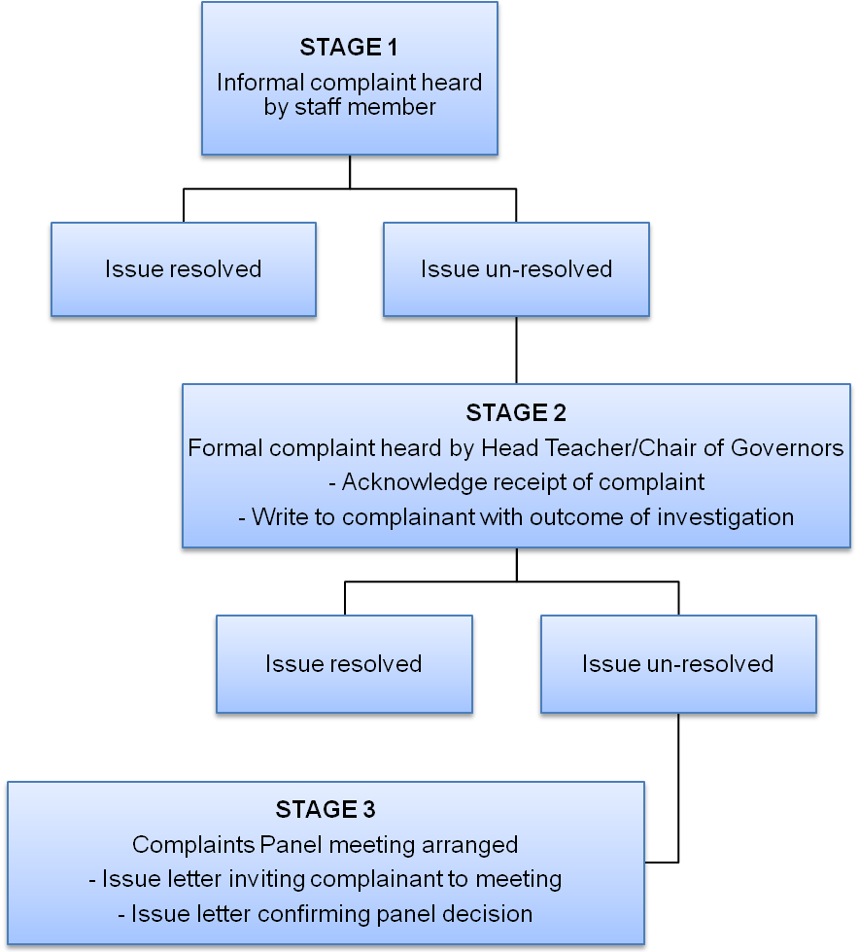
Appendix C: Complaint Form
ACADEMY - COMPLAINT FORM

Please complete and return to the complaints co-ordinator who will acknowledge receipt and explain the complaints process.

Your Name ……………………………………………………………

Pupil’s name …………………………………………………………

Your relationship to the pupil (if relevant) ……………………………………………

Address ………………………………………………………………………………………………….

……………………………………………………………………………………………………………….

Telephone number (day) …………………………………………………………..

Telephone number (evening) ……………………………………………………..

Please give brief details of your complaint ………………………………………………………………………………………………………………………………………………………………….………………………………………………………………………………………………………………………………………………………………….
………………………………………………………………………………………………………………………………………………………………….

What action, if any, have you already taken to try to resolve your complaint? (Who did you speak to and what was their response?)

………………………………………………………………………………………………………………………………………………………………………………………………………………………………………………………………………………………………………………………………………………………………………………………………………………………………………………………………………………………………………

What actions do you feel might resolve the problem at this stage?
……………………………………………………………………………………………………………………………………………………………………………………………………………………………………………………………………………………………………………………………………………………………………………………………………………………………………………………………………………………………………….
Are you attaching any paperwork? If so, please give details

………………………………………………………………………………………………………………………………………………………………………………………………………………………………………………………………………………………………………………………………………………………………………………………………………………………………………………………………………………………………………………………………………………………………………………………………………………………………………………………………………….

Signature ………………………………………………… (Complainant)

Date ………………………………..

Appendix D: Policy on unacceptable behaviour

The Governing Body recognises that it is the last resort for complainants. They also have a duty to ensure the safety and welfare of pupils, parents and staff.

The Governing Body is committed to dealing with all complaints fairly and impartially and to providing a high quality service to those who make them. As part of this service it would not normally limit the contact complainants have. However the Governing Body does not expect the Academy’s staff to tolerate behaviour by complainants which is unacceptable, for example, which is abusive, offensive or threatening, and it will take action to protect staff from that behaviour. This applies to unacceptable behaviour on any part of the school premises, including the yard.

If the Head Teacher considers that a complainant’s behaviour is unacceptable the complainant will be told why their behaviour is deemed to be unreasonable and will be asked to change it. If the unacceptable behaviour continues the Head Teacher will take action to restrict the complainant’s contact with academy.

Unacceptable actions and behaviours

These are some of the actions and behaviours of unreasonable and unreasonably persistent complainants which academy often find problematic. It is by no means an exhaustive list and local factors may vary, but these are examples that frequently come to our attention.
- Foul and abusive language towards staff, other parents and pupils.
- Behaviour that staff consider to be harassing and intimidating, including in person, over the telephone, or any other type of communication.
- Undermining school policies by actively encouraging pupils to ignore staff requests.
- Making unnecessarily excessive demands on the time and resources of staff, by for example excessive telephoning or sending emails to numerous staff, writing lengthy complex letters every few days and expecting immediate responses.
- Combinations of some or all of these.

The decision to restrict access to our school will be taken by the Head Teacher. Any restrictions imposed will be appropriate and proportionate. The options most likely to considered are:
- requesting contact in a particular form (for example, letters only);
- requiring contact to take place with a named member of staff;
- restricting telephone calls to specified days and times; and/or
- asking the complainant to enter into an agreement about their conduct.

In all cases we will write to tell the complainant why we believe his or her behaviour is unacceptable, what action we are taking and the duration of that action.

Where a complainant continues to behave in a way which is unacceptable, we may decide to terminate contact with that complainant and discontinue any investigation into their complaint. However the Governing Body will seek to limit any detriment to any pupils who attend the academy, as far as is reasonable within these circumstances e.g. access to parents evenings, newsletters, and any other correspondence.

Where the behaviour is so extreme that it threatens the immediate safety and welfare of the academy’s staff, we will consider other options, for example reporting the matter to the police or taking legal action. In such cases, we may not give the complainant prior warning of that action.

Appendix E: Policy on unreasonably persistent complainants

The Governing Body recognises that it is the last resort for complainants. It is also accountable for the proper use of public money and must ensure that that money is spent wisely and achieves value for complainants and the wider public.

The Governing Body is committed to dealing with all complaints fairly and impartially and to providing a high quality service to those who make them. As part of this service it does not normally limit the contact complainants have with the academy.

However there are a small number of complainants who, because of their frequent contact with the academy, hinder consideration of their or other people’s, complaints. Such complainants are referred to as ‘unreasonably persistent complainants’ and, exceptionally, the Head Teacher will take action to limit their contact with academy.

Actions and behaviours of unreasonable and unreasonably persistent complainants

These are some of the actions and behaviours of unreasonable and unreasonably persistent complainants which schools often find problematic. It is by no means an exhaustive list and factors may vary, but they are examples that may come to our attention.
- Refusing to specify the grounds of a complaint, despite offers of assistance with this from the academy’s staff.
- Refusing to co-operate with the complaints investigation process while still wishing their complaint to be resolved.
- Refusing to accept that issues are not within the remit of a complaints procedure despite having been provided with information about the procedure’s scope.
- Insisting on the complaint being dealt with in ways which are incompatible with the adopted complaints procedure or with good practice.
- Making what appear to be groundless complaints about the staff dealing with the complaints, and seeking to have them replaced.
- Changing the basis of the complaint as the investigation proceeds and/or denying statements he or she made at an earlier stage.
- Introducing new information which the complainant expects to be taken into account and commented on, or raising large numbers of detailed questions which are particularly time consuming and costly to respond to and insisting they are all fully answered.
- Electronically recording meetings and conversations without the prior knowledge and consent of the other persons involved.
- Adopting a 'scattergun' approach: pursuing a complaint or complaints with the academy and, at the same time, with a Member of Parliament/a councillor/the authority’s independent auditor/the Local Authority/local police/solicitors/the Ombudsman/OFSTED.
- Making unnecessarily excessive demands on the time and resources of staff whilst a complaint is being looked into, by for example excessive telephoning or sending emails to numerous academy staff, writing lengthy complex letters every few days and expecting immediate responses.
- Submitting repeat complaints, after complaints processes have been completed, essentially about the same issues, with additions/variations which the complainant insists make these 'new' complaints which should be put through the full complaints procedure.
- Refusing to accept the decision – repeatedly arguing the point and complaining about the decision.
- Combinations of some or all of these.

The decision to restrict access to the academy will be taken by the Head Teacher and will normally follow a prior warning to the complainant. Any restrictions imposed will be appropriate and proportionate. The options we are most likely to consider are:
- requesting contact in a particular form (for example, letters only);
- requiring contact to take place with a named member of staff;
- restricting telephone calls to specified days and times; and/or
- asking the complainant to enter into an agreement about their future contacts with us.

In all cases where we decide to treat someone as an unreasonably persistent complainant, we will write to tell the complainant why we believe his or her behaviour falls into that category, what action we are taking and the duration of that action. We will also tell them how they can challenge the decision if they disagree with it. If we decide to carry on treating someone as an unreasonably persistent complainant and we are still investigating their complaint six months later, we will carry out a review and decide if restrictions will continue.

Where a complainant whose case is closed persists in communicating with us about it, we may decide to terminate contact with that complainant. In such cases, we will read all correspondence from that complainant, but unless there is fresh evidence which affects our decision on the complaint we will simply acknowledge it or place it on the file with no acknowledgement.

New complaints from people who have come under the unreasonably persistent complainant’s policy will be treated on their merits.

________________________________________________________________________

Copyright Avec Partnership 2014

