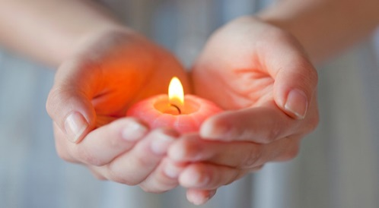
At this sad time our thoughts and prayers are with Drew, his family and friends.
If you would like some support and advice we hope that the following information and links will be helpful.
When someone dies
Having a friend die can be very upsetting. People experience a variety of responses and emotions. Below is a list of some of them – but this is not an extensive list and it’s ok if you don’t feel any of these, or all of them at the same time. The important thing is to let people know how you are feeling. In school staff are around to support and listen to you or maybe you were prefer to speak with a friend or family member.
Sad that your friend has died and won't have a chance to grow up.
Sad for your friend's parents and family.
Lonely because you really miss your friend.
Angry because young people aren't supposed to get cancer and die.
Angry that the doctors, God, or someone couldn't keep your friend from dying.
Angry because other people just don't understand.
Relief to still be alive.
Guilty to still be alive when a friend has died.
Scared to die, too.
Scared of being friends with other people because they might die, too.
Hurt because it really does hurt to lose a friend.
Helpless as there was nothing you could do to prevent the death.
Hopeless that you will ever feel better again.
Glad to have had the chance to have such a good friend.
Glad the suffering is over for your friend.
When a friend dies, especially after a hard battle with an illness or injury, it is OK to be glad that the struggle is over and to be upset that the person died.

You may think:
- "Why did this happen? It's not fair!"
- "This really hurts."
- "It was getting so hard, I'm glad the suffering has ended."
- "What's going to happen to me?"
- "Why him and not me?"
- "I wish I would have been nicer to him."
- "No one should have to go through this."
What can you do if you have some or all of these feelings and thoughts? All of these thoughts and feelings are part of grief, and grief is what happens to you on the inside when someone dies. It's important to pay attention to grief and find some ways to help yourself feel and do even a little bit better as time goes on.

Here are some things that might be helpful:

- Talk to someone about what it's like for you having your friend die. Pick someone you trust and who can really listen. This could be a friend or family member or a teacher or support worker in school.
- Find another way to express what it's like for you on the inside—writing, art, music, or a memorial project.
- Send a card or some kind of expression of sympathy to the family. If you can, tell them what you will always remember about your friend.
- Find something to do that connects you to your friend—something your friend liked to do or fits with your friend's personality.
- Take some time alone to think—just don't stay away too long.
- Make use of your beliefs about spirituality or your faith group, if you have one.
- Spend time with your friends doing fun things.
- Talk about your friend who died—keep the memory of your friend alive even if it hurts, especially at first.
- Remember that one of the best ways to honour someone's life is to live and remember what you learned about life from your friend.
For additional information and support click on the links below:

Winston’s Wish has a Freephone Helpline: 08088 020 021 (Monday – Friday, 9am- 5pm. Or email ask@winstonswish.org

Winston’s wish Ten ways for coping with grief at Christmas and how to support a bereaved friend

How children grieve

Understanding feelings of loss and grief.

Advice for parents to support their child when a friend dies’.

Resources, organisations and information for our local area

Free, safe and anonymous online support and counselling for young people. Monday – Friday 12pm – 10pm, Saturday – Sunday 6pm – 10pm

Our own St Wilfrid’s Wellbeing page has lots of helpful information and links for support

