#20placestovisit
 | Photo | Challenge
- The Colosseum, Italy | 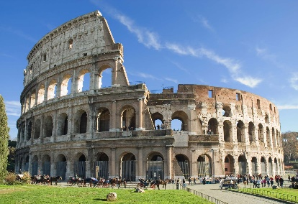 | - When was it built? Between 72 A.D and 80 A.D  - Who was Emperor at the time? Emperor Vespasian  - How many people could the Colosseum sit? 50,000
- The Acropolis, Greece | 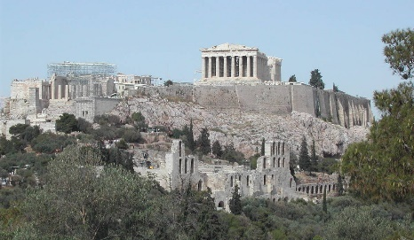 | - When was it built? 525 BC  - Which goddess was it built to honour? Athena  - What was the original purpose of the Acropolis in Athens? As a fortress
- Great Wall of China, China | 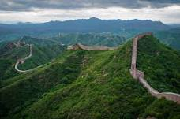 | - How long would it take to walk the entire wall? 18 months  - When were the earliest parts of the wall built? 220–206 BC  - What do the Chinese call the wall? Long Rampart(s) or Ten-Thousand Mile Long Wall
4. Angel Falls, Venezuela | 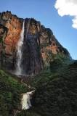 | - In what continent is the waterfall located? South America  - How long is the biggest drop? 807m  - What river does the waterfall occur on? Churún River
5. The Taj Mahal, India | 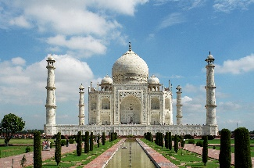 | - Which river is it on the south bank of? Yamuna  - How much was it thought to have cost? 32 million rupees  - How high is the marble dome on the top? 35m
6. Sydney Opera House, Australia | 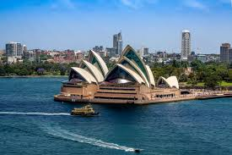 | - Which state of Australia is it found in? New South Wales  - What is the Aboriginal name for it? Tu-bow-gule meaning meeting of the waters  - Who opened the building? Queen Elizabeth II on 20th October, 1973
7. Giant's Causeway,  Northern Ireland | 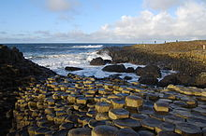 | 1. How many blocks make up the causeway? 40,000  2. What shape are most of the blocks? Hexagonal  3. In Irish myth, what created the causeway? A fight between 2 giants
8. Petra, Jordan | 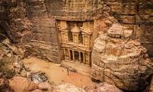 | 1. Which groups of people was it the capital for? Nabataeans  2. How many people was it home to? 20-30 thousand people  3. Which movie was the site used for in the final scene? Indiana Jones and the Last Crusade
9. Chitchen Itza, Mexico | 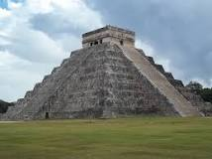 | 1. Who was the large city built by? Mayans  2. What is the term Itza believed to mean? Water magicians  3. What rock type is the pyramid made of? Limestone
10. Statue of Liberty, USA | 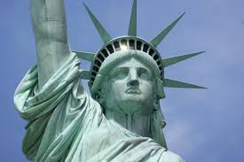 | 1. Which island is it found on? Liberty  2. Who is the statue based on? Libertas, the Roman goddess of liberty  3. Where was it constructed? France
11. Stonehenge, UK | 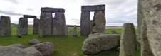 | 1. Which county is it found in? Wiltshire  2. Which group of people is though to have built it? Druids  3. Why was it built? Religious worship
12. Mt Fuji, Japan | 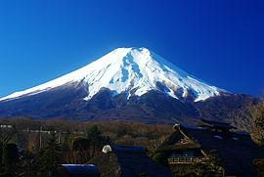 | 1. Mt Fuji is one of three what? Holy Mountains  2. What tectonic landform is this?  Volcano / Stratovolcano  3. According to Japanese culture, what would only a fool do on Mt Fuji? Climb it twice
13. Table Mountain, South Africa | 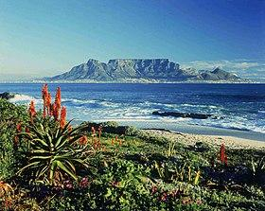 | 1. Which city is it found in? Cape Town  2. It is often covered in cloud which is known as what? The 'Table cloth'  3. The rocks of the mountain are thought to be as old as? 600 million years old
14. Eiffel Tower, France | 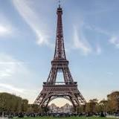 | 1. What is the height of the tower to the tip? 324m to tip  2. Where was it originally intended for? Barcelona, Spain  3. What has to be done every 7 years by hand? The tower has to be repainted!
15. Great Barrier Reef, Australia | 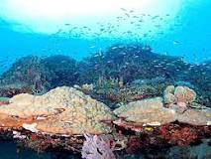 | 1. How many individual reefs are there? 2900  2. How many species of fish live here? 1,500+  3. What temperature change is needed for coral bleaching to happen? 1 degree Celsius
16. Grand Canyon, USA | 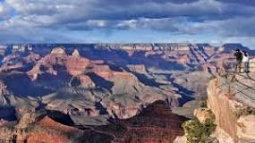 | 1. What river carved this out? Colorado River  2. What US state is it in? Arizona  3. Which group of people consider it a holy place? Pueblo people
17. Machu Picchu, Peru | 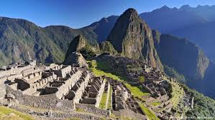 | 1. What does Machu Picchu mean in the Quechua language? Old mountain  2. What is the height of the site above sea level? 8,047 feet (2452m) above sea level.  3. What mountain range is it in? Andes Mountains
18. Antarctica | 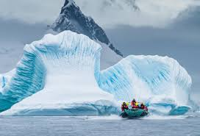 | 1. Antarctica is the world’s largest what? Desert  2. What percentage of the world’s ice can be found there? 90%  3. What is the lowest temperature recorded there? −89.2 °C
19. Easter Island, Pacific Ocean | 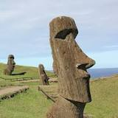 | 1. Easter Island is part of which country? Chile  2. What is the native name of the statues? Moai  3. Why is it called Easter Island? Discovered on Easter Sunday (1722)
20. Christ the Redeemer, Brazil | 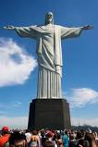 | 1. The statue is located on the top of which mountain? Corcovado  2. Which city is the statue in? Rio de Janeiro  3. How far do the arms stretch? 92 feet (28m) wide

