#20placestovisit
 | Photo | Challenge
- The Colosseum, Italy | 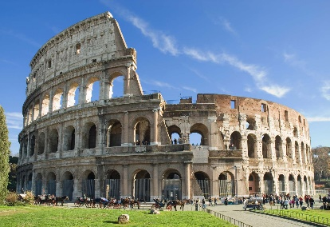 | - When was it built?  - Who was Emperor at the time?  - How many people could the Colosseum sit?
- The Acropolis, Greece | 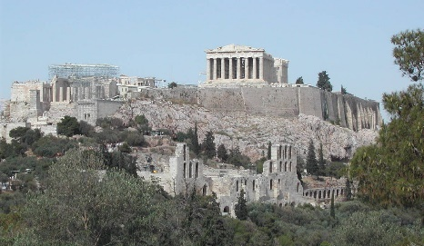 | - When was it built?  - Which goddess was it built to honour?  - What was the original purpose of the Acropolis in Athens?
- Great Wall of China, China | 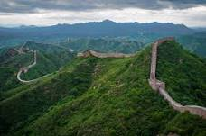 | - How long would it take to walk the entire wall?  - When were the earliest parts of the wall built?  - What do the Chinese call the wall?
4. Angel Falls, Venezuela | 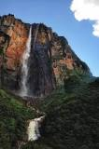 | - In what continent is the waterfall located?  - How long is the biggest drop?  - What river does the waterfall occur on?
5. The Taj Mahal, India | 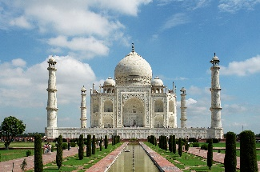 | - Which river is it on the south bank of?  - How much was it thought to have cost?  - How high is the marble dome on the top?
6. Sydney Opera House, Australia | 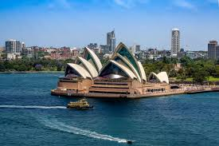 | - Which state of Australia is it found in?  - What is the Aboriginal name for it?  - Who opened the building?
7. Giant's Causeway,  Northern Ireland | 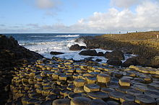 | 1. How many blocks make up the causeway?  2. What shape are most of the blocks?  3. In Irish myth, what created the causeway?
8. Petra, Jordan | 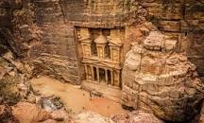 | 1. Which groups of people was it the capital for?  2. How many people was it home to?  3. Which movie was the site used for in the final scene?
9. Chitchen Itza, Mexico | 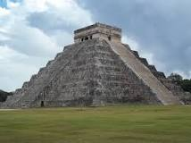 | 1. Who was the large city built by?  2. What is the term Itza believed to mean?  3. What rock type is the pyramid made of?
10. Statue of Liberty, USA | 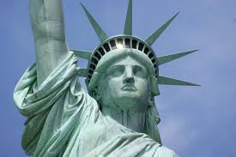 | 1. Which island is it found on?  2. Who is the statue based on?  3. Where was it constructed?
11. Stonehenge, UK | 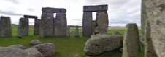 | 1. Which county is it found in?  2. Which group of people is though to have built it?  3. Why was it built?
12. Mt Fuji, Japan | 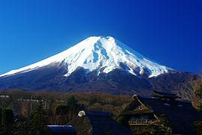 | 1. Mt Fuji is one of three what?  2. What tectonic landform is this?  3. According to Japanese culture, what would only a fool do on Mt Fuji?
13. Table Mountain, South Africa | 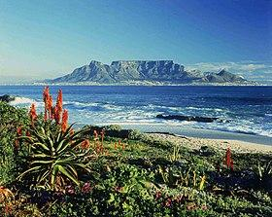 | 1. Which city is it found in?  2. It is often covered in cloud which is known as what?  3. The rocks of the mountain are thought to be as old as?
14. Eiffel Tower, France | 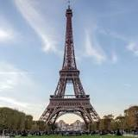 | 1. What is the height of the tower to the tip?  2. Where was it originally intended for?  3. What has to be done every 7 years by hand?
15. Great Barrier Reef, Australia | 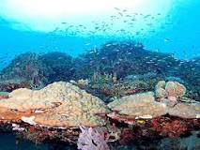 | 1. How many individual reefs are there?  2. How many species of fish live here?  3. What temperature change is needed for coral bleaching to happen?
16. Grand Canyon, USA | 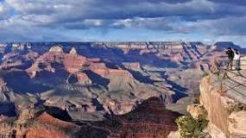 | 1. What river carved this out?  2. What US state is it in?  3. Which group of people consider it a holy place?
17. Machu Picchu, Peru | 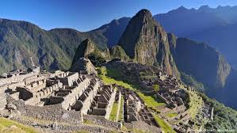 | 1. What does Machu Picchu mean in the Quechua language?  2. What is the height of the site above sea level?  3. What mountain range is it in?
18. Antarctica | 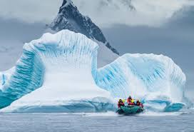 | 1. Antarctica is the world’s largest what?  2. What percentage of the world’s ice can be found there?  3. What is the lowest temperature recorded there?
19. Easter Island, Pacific Ocean | 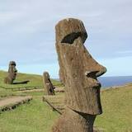 | 1. Easter Island is part of which country?  2. What is the native name of the statues?  3. Why is it called Easter Island?
20. Christ the Redeemer, Brazil | 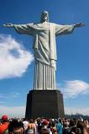 | 1. The statue is located on the top of which mountain?  2. Which city is the statue in?  3. How far do the arms stretch?

