St. Wilfrids R.C College

FAQ’s

When do you get lockers and what can you put in?

You will be allocated a locker in September. You must put in your mobile phone; outdoor coats and you could leave in any books/equipment/kit that you don’t need for the morning/afternoon.

What happens if you get lost?

We have some fantastic students who will help point you in the right direction. Also, staff will be in the corridors and around the school helping you find your way to lessons. Although its a big school, you will find your way around in no time, so don’t worry about getting lost.

What is the food like?/ What sort of food do we offer?

Rest assured the food will be FANTASTIC. As yet we don’t know what we can offer until we get more guidance from the Government given the current situation.

Below is a sample menu from 2019;
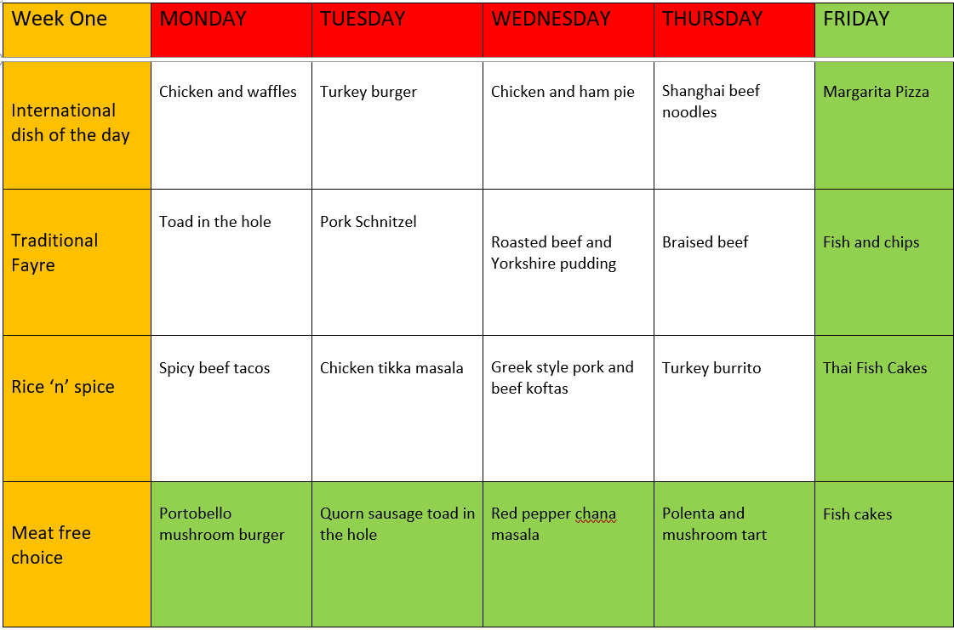

The current price for a two-course meal is £2.20 and at the minute we are not aware of any plans to increase this for next year. We operate a cashless system, you can top up online or at the machines in school.

During normal times we are part of the Magic Breakfast organisation who fund a free breakfast scheme and they have extended the offer for another term. In normal times It would be hot bagel or bowl of cereal as a choice. At the minute we don’t know how breakfast or lunches will be running in September, it one of those “watch this space scenarios”.

Can I bring in a packed lunch?

Yes, of course, you will be able to eat your packed lunch in school in Saints Café with your friends

How much homework will I receive?

At St. Wilfrids we have a homework policy, which is summarised below:

Frequency
- Class = once per week = 5 homework tasks per module
- Class = more than once per week = 10 homework tasks per module

Amount
- KS3 – 30 mins a week per subject

Homework online
Homework might be set online using secure learning platforms such as Google Classroom, MathsWatch, Seneca and others.

Homework recording
All homework must be recorded in a student’s planner including the due date.

Will I see my friends?

Even if you are not the same tutor group or teaching classes as your friends you will be able to see them before school and during break and lunch times.

What trips can I go on?

At the moment we don’t know when we will be able to run trips again. However, in normal circumstances each department seek to offer students with appropriate educational activities to help enrich the curriculum. They do vary each year, but some examples of recent trips are;

- Geography department; Iceland,

- History Department: Year 8 Visit to Beamish, First World War Battlefields in France and Belgium and Berlin

- Business Department; Beamish Museum

- MFL: Manadrin trip to Chinatown, Mandarin Cinema trip, Cinema trip to watch a foreign film at the Tyneside Cinema, KS3 trip to France

- Science Department: Body works in London

- Technology: Caterpillar, Nissan and Teeside University STEM days recently.

- Ski Trip: Italy

- RE Department: Youth Village – Year 7 Retreat. God Camp for Years 9 onwards.

What clubs can I join ?

There are so many clubs on offer. Most departments in school run lunch time or afterschool clubs. Exact details will be available in September. Below is an example of a typical term of extra-curricular activities taken from 2019s;

Week 1 | Before School | Break | Lunch | After School
Mon |  | Music  Y7-9 Keyboard Club – 1.91 | Active Lunch  Y8 Trampolining – LLB  Y7+8 Basketball – ATR  Y7+8 Girls Football - JTR  Music  Keyboard Club + Music Drop-in - 1.90  Games  Y7+8 Games Club – HKG/CPN – 1.02/1.03  Y9-11 Games Club – HKG/CPN – 1.02/1.03  Debate Club  Debate Club – TMY – English Corridor | Sport  Gymnastics – LLB  Girls Netball - SBN  Homework  Homework Club - DHN – 1.86
Tues | Reading  Y7 Reading Intervention – 1.02 – 8.10-8.40am |  | Active Lunch  Y9-11 Fitness – HNL  Y9-11 Trampolining - PRE  Music  Y7+8 Junior Choir – 1.91  Games  Y7+8 Games Club – HKG/CPN – 1.02/1.03  Y9-11 Games Club – HKG/CPN – 1.02/1.03  Eco Team  Y7+8 SWET St. Wilfrid’s Eco Team - 2.61 | Homework  Homework Club – DHN – 1.86
Wed | Reading  Y7 Reading Intervention – 1.02 – 8.10-8.40am |  | Active Lunch  Y8 Trampolining – SBN  Y7+8 Basketball – JTR  Y9-11 Fitness – ATR  Y9-11 Trampolining - LME  Music  Y7+8 Steel Pans – 1.91  Games  Y7+8 Games Club – HKG/CPN – 1.02/1.03  Y9-11 Games Club – HKG/CPN – 1.02/1.03 | Sport  Trampolining Club – SBN/JTR  Music  Junior Orchestra – 1.91 – 3:10-3:50pm  Senior Orchestra – 1.91 – 3.10-4.30pm  Homework  Homework Club – DHN – 1.86
Thurs | Music  Worship Band – 1.91  Reading  Y7 Reading Intervention – 1.02 – 8.10-8.40am |  | Active Lunch  Y9-11 Trampolining – SBN  Y9-11 Basketball - PRE  Music  Y9-11 Key Board Club + Music Drop In – 1.91  MFL  Y7-8 Languages Club – MZN/RHE – 2.52  Games  Y7+8 Games Club – KGN/CPN – 1.02/1.03  Y9-11 Games Club – HKG/CPN – 1.02/1.03 | Sport  Badminton – HNL, Girls Rugby - JTR  Music  ABRSM Theory – 1.91  Design Technology  DT Club – LBH – 1.74  Homework  Homework Club – DHN – 1.86  STEM  STEM Club – MWS – 2.34  Art  I-media/Photoshop - 1.76
Fri | Music  Guitar Club – Drum Room  Reading  Y7 Reading Intervention – 1.02 – 8.10-8.40am |  | Active Lunch  Y7-8 Basketball - HNL  Y7 Trampolining – JTR  Y9-11 Trampolining – SBN  Music  Y9-13+Staff - Senior Choir – 1.91  Games  Y7+8 Games Club – HKG/CPN – 1.02/1.03  Y9-11 Games Club – HKG/CPN – 1.02/1.03 | Social Skills  Social Group – 2.14  Homework  Homework Club – DHN – 1.86  Music  Y10-13 - Composition Clinic – 1.91

Who do I speak to if I have a problem ?

There are many members of staff who you can go to with a problem. You could go to your tutor, you will be seeing them every day so you will get to know each other very well. You will also have a Head of House and Assistant Head of House.

What sports will I do in PE?

At the moment we are unsure if normal PE lessons will go ahead, however, here is the list of activities you can expect in normal circumstances:

- Girls – trampolining, netball, football, gymnastics, basketball, handball, rugby, dance, athletics, rounders, tennis, cricket.
- Boys – football, handball, trampolining, basketball, health related fitness, rugby, badminton, athletics, tennis, cricket, softball.

What sort of science experiments will we do?

In Science you will have the opportunity to do lots of experiments throughout your time at St Wilfrids. You will have a range of science practical’s in Year 7. We will start with basic lab safety and in the first week you will get your Bunsen burner license! How exciting is that? You will then learn to use microscopes and identify objects under a microscope, measuring the abundance of different organisms in ecosystems. You will also look at separating mixtures using separation techniques in chemistry and testing different acids and alkalis using indicators. You will get the opportunity to make your own parachutes to investigate terminal velocity and use light rays to investigate reflection and refraction. Finally, you will build your own circuits when discovering how electrical current and voltage behaves.

