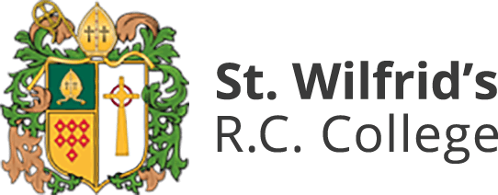

Covid-19 Protocols for Teaching Interviews

Teaching interviews taking place during the C-19 pandemic will be held in two parts:
- Teaching a lesson on-site; please see below for associated protocols
- Completing tasks & interviews virtually; details of how to join the virtual meetings will be shared with you in advance of the day

Arrival at St. Wilfrid’s R.C. College
- Use the Temple Park Road entrance, and report to main reception
- When in the building and not teaching, all staff and students must wear a face mask
- Hands must be washed with soap & water at the hand cleaning station next to reception upon entering the main part of the building
- Interviewees will be escorted from main reception to the teaching room by a member of St. Wilfrid’s staff
Teaching the lesson
- Staff and students do not wear masks during lessons
- There is a ‘teacher box’ marked out at the front of all classrooms; the teacher must remain in this box at all times
- Students must remain in their allocated seats, and facing forward
- Students must not share any materials (e.g. calculators)
- Students are not permitted to use the toilets during lesson time, unless they have a toilet pass
- At the end of the teaching episode, the interviewee must wipe down the keyboard, mouse, and teacher desk using the cleaning wipes provided
- Staff must also sanitize their hands on leaving the room, using the sanitizer provided
Leaving site
- Interviewees will be escorted back to main reception by a member of St. Wilfrid’s staff
- Hands must be washed with soap & water at the hand cleaning station next to reception upon exiting the main part of the building
- Interviewees must head directly off site and prepare for the virtual aspects of the interview

