20 May 2021
Dear Student

Following the half term break we will focus on ‘bridging work’ to help with your preparations for the next stage of your learning journey. You are expected to attend school from Tuesday to Thursday each week, with the timings of each day shown in the tables over the page.

You will be given the opportunity to experience what sixth form life is like at St Wilfrid’s by attending sixth form lessons and tutorials in the sixth form centre. Sixth form dress code should be followed.

Your form tutor will ask you to select a subject from each of the following option blocks to attend as per the timetables provided over the page.

The subject options are as follows:
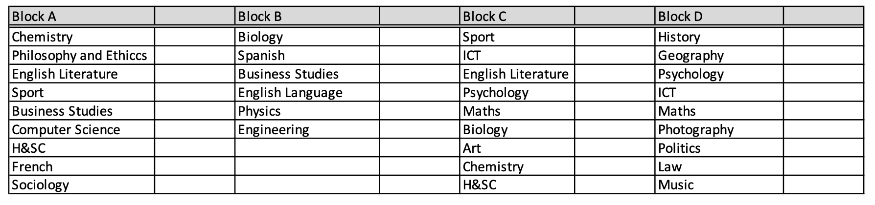

We are looking forward to welcoming you into our sixth form for these taster sessions.

Kind regards

Mrs Ritchie

Acting Head of School

Week 1

Day | Times | Details
Tuesday 8 June | 8.45 – 12.10 | 8.45 – 9.00 Registration  9.00-11.00 Block A lesson  11.00-11.15 Break  11.15-12.10 Tutorial
Wednesday 9 June | 8.45 – 12.10 | 8.45 – 9.00 Registration  9.00-11.00 Block C lesson  11.00-11.15 Break  11.15-12.10 Tutorial
Thursday 10 June | 8.45 – 12.10 | 8.45 – 9.00 Registration  9.00-11.00 Block D lesson  11.00-11.15 Break  11.15-12.10 Block B lesson

Week 2

Day | Times | Details
Tuesday 15 June | 8.45 – 3.10 | 8.45 – 9.00 Registration  9.00-11.00 Block A lesson  11.00-11.15 Break  11.15-12.10 Tutorial  1.10-3.10 Block D lesson
Wednesday 16 June | 8.45 – 12.10 | 8.45 – 9.00 Registration  9.00-11.00 Block C lesson  11.00-11.15 –Break  11.15-12.10 Tutorial
Thursday 17 June | 8.45 – 12.10 | 8.45 – 9.00 Registration  9.00-10.00 Tutorial  10.00-11.00 Block B lesson (part 1)  11.00-11.15 Break  11.15-12.10 Block B lesson (part 2)

Week 3

Day | Times | Details
Tuesday 22 June | 8.45 – 12.10 | 8.45 – 9.00 Registration  9.00-11.00 Block A lesson  11.00-11.15 Break  11.15-12.10 Tutorial
Wednesday 23 June | 8.45 – 12.10 | 8.45 – 9.00 Registration  9.00-11.00 Block C lesson  11.00-11.15 Break  11.15-12.10 Tutorial
Thursday 24 June | 8.45 – 12.10 | 8.45 – 9.00 Registration  9.00-11.00 Block D lesson  11.00-11.15 Break  11.15-12.10 Block B lesson

