A Level English Language
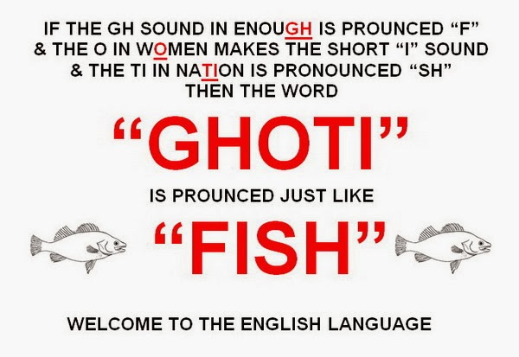
Bridging Work

Name:
Watching lectures:
Language 1: word classes
https://www.youtube.com/watch?v=XlB1ohRQfZM

Language 2: lexis and semantics
https://www.youtube.com/watch?v=enAKXRQphbQ
Language 3: grammar basics https://www.youtube.com/watch?v=VMMQ7BgQ9zk
Language 3b: advanced grammar
https://www.youtube.com/watch?v=6pcnfc782yc
Language 4: pragmatics
https://www.youtube.com/watch?v=30CGZ0NaY9c
Language 5: morphology
https://www.youtube.com/watch?v=3BExnLInLDo
Language 6: discourse and rhetoric
https://www.youtube.com/watch?v=p4f0n_2SQxE
Language 7: phonology
https://www.youtube.com/watch?v=p4f0n_2SQxE
Language 8: spoken language
https://www.youtube.com/watch?v=JJZRO-NDFgg

Remember to make notes on these – these elements are vital to your success at A Level

Week One
- Watch the first YouTube lecture and make notes below
Word Classes

- Read the text below and answer the questions:

BLEAK HOUSE
by Charles Dickens
CHAPTER I
In Chancery
London. Michaelmas term lately over, and the Lord Chancellor sitting in Lincoln's Inn Hall. Implacable November weather. As much mud in the streets as if the waters had but newly retired from the face of the earth, and it would not be wonderful to meet a Megalosaurus, forty feet long or so, waddling like an elephantine lizard up Holborn Hill. Smoke lowering down from chimney-pots, making a soft black drizzle, with flakes of soot in it as big as full-grown snowflakes--gone into mourning, one might imagine, for the death of the sun. Dogs, undistinguishable in mire. Horses, scarcely better; splashed to their very blinkers. Foot passengers, jostling one another's umbrellas in a general infection of ill temper, and losing their foot-hold at street-corners, where tens of thousands of other foot passengers have been slipping and sliding since the day broke (if this day ever broke), adding new deposits to the crust upon crust of mud, sticking at those points tenaciously to the pavement, and accumulating at compound interest.
Fog everywhere. Fog up the river, where it flows among green aits and meadows; fog down the river, where it rolls deified among the tiers of shipping and the waterside pollutions of a great (and dirty) city. Fog on the Essex marshes, fog on the Kentish heights. Fog creeping into the cabooses of collier-brigs; fog lying out on the yards and hovering in the rigging of great ships; fog drooping on the gunwales of barges and small boats. Fog in the eyes and throats of ancient Greenwich pensioners, wheezing by the firesides of their wards; fog in the stem and bowl of the afternoon pipe of the wrathful skipper, down in his close cabin; fog cruelly pinching the toes and fingers of his shivering little 'prentice boy on deck. Chance people on the bridges peeping over the parapets into a nether sky of fog, with fog all round them, as if they were up in a balloon and hanging in the misty clouds.
Gas looming through the fog in divers places in the streets, much as the sun may, from the spongey fields, be seen to loom by husbandman and ploughboy. Most of the shops lighted two hours before their time--as the gas seems to know, for it has a haggard and unwilling look.
The raw afternoon is rawest, and the dense fog is densest, and the muddy streets are muddiest near that leaden-headed old obstruction, appropriate ornament for the threshold of a leaden-headed old corporation, Temple Bar. And hard by Temple Bar, in Lincoln's Inn Hall, at the very heart of the fog, sits the Lord High Chancellor in his High Court of Chancery.
Never can there come fog too thick, never can there come mud and mire too deep, to assort with the groping and floundering condition which this High Court of Chancery, most pestilent of hoary sinners, holds this day in the sight of heaven and earth.

1. Read the opening passage of Bleak House - circle any instance of the words fog, mud, mire and lead. Do you notice any patterns being built?

2. Make a list of words that you associate with the following:
Fog | Mud | Mire | Lead

3. Explain the associations that the words have:

- Do they refer to the weather?
- Condition of soil?
- Or more than that? E.g feelings, ideas

4. Highlight every sentence that begins with a monosyllabic concrete noun

5. How many determiners are used?

6. Highlight any instances of alliteration and repetition.

7. List any present progressive verbs. What are they associated with? Explain the effect.

8. List all the examples of personification.

9. List examples of: adjectives of quality and superlative adjectives

Week Two
- Watch the second YouTube lecture and make notes below
Lexis and Semantics

Look at the word clouds below, based on the most common words found in the opening pages of two famous children’s books.

- Can you identify which novels they are from, simply by using the lexis? Look for lexical clues to help you, such as examples of informal, archaic or obsolete lexis etc.

- Which kinds of words feature most frequently? The larger the word, the more frequently it is used in the text.

- How many different lexical fields can you identify? For example, you might notice that there is a lexical field of spying in Text B (spying, discover, pretending etc.). Make a list for each text, with example lexis.

- How do the word choices and lexical fields compare in each text?

- What conclusions, if any, can you draw about the writers’ lexical choices?

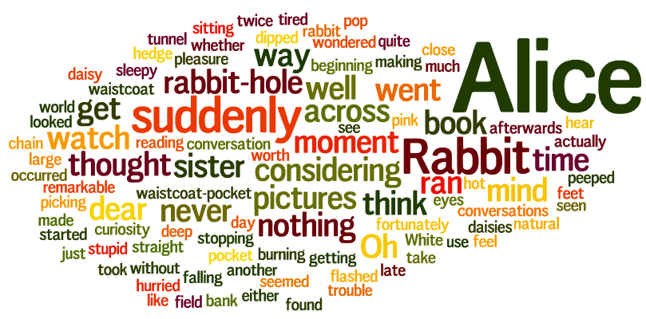

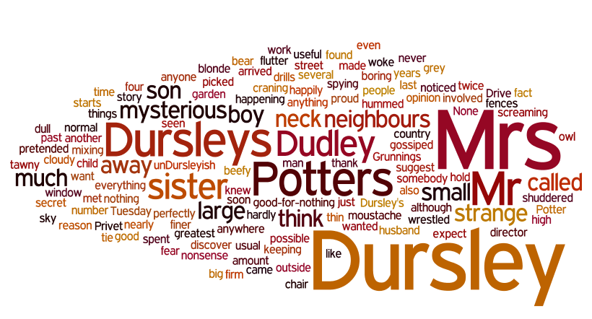

Week Three
- Watch the third YouTube lecture and make notes below
Grammar Basics

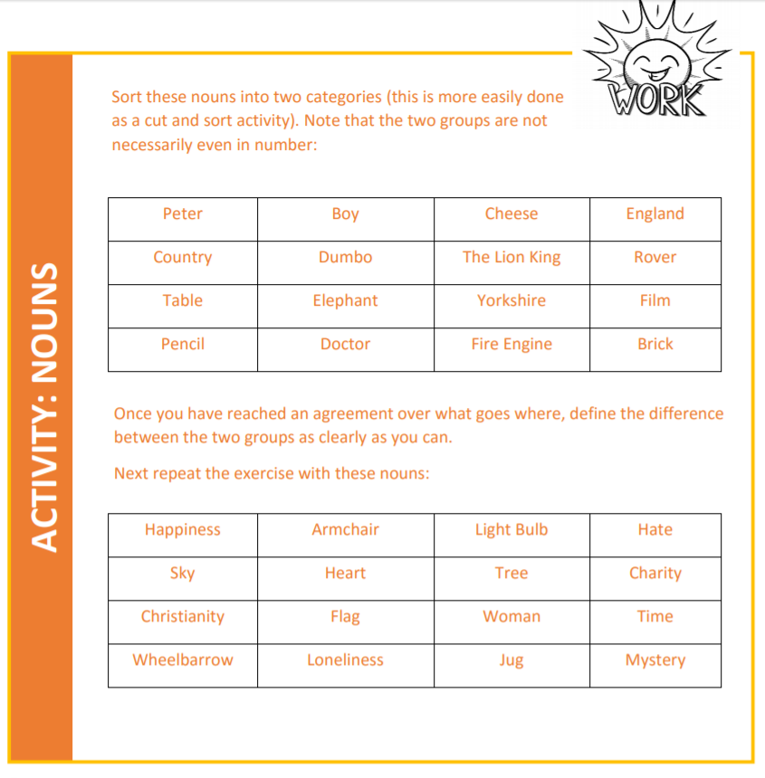

Week Four
- Watch the fourth and fifth YouTube lecture and make notes below
Advanced grammar and pragmatics

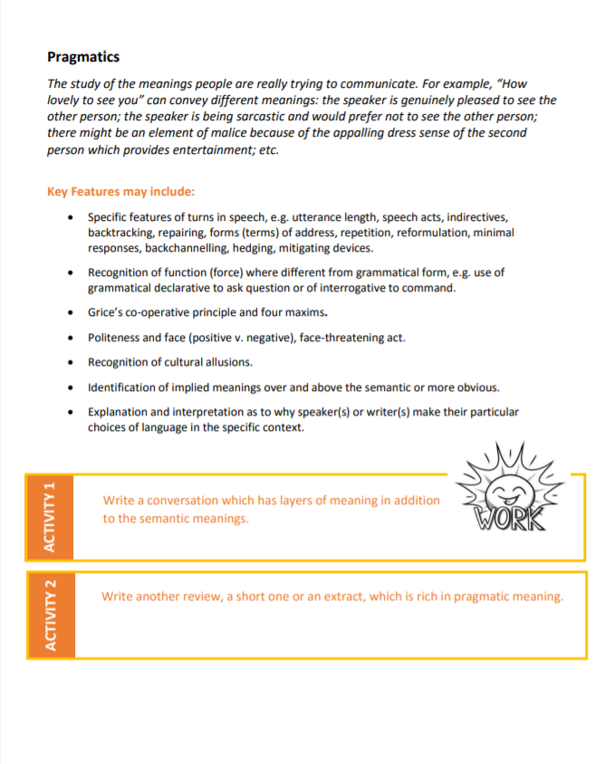

Week Five
- Watch the sixth and seventh YouTube lecture and make notes below
Morphology / discourse

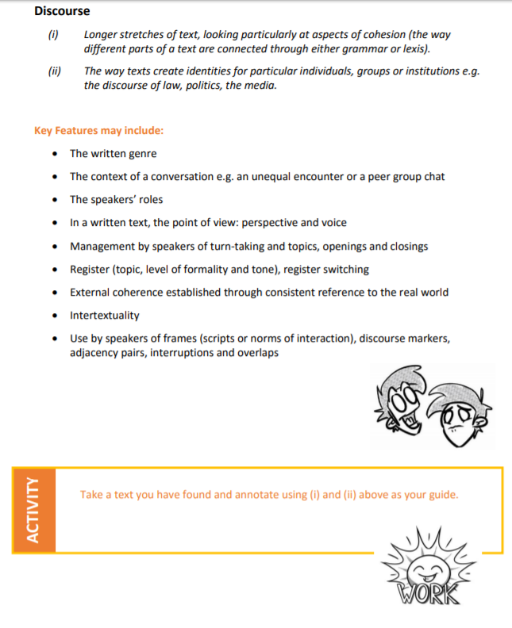

Week Six
- Watch the eighth and ninth YouTube lecture and make notes below
Phonology / spoken language

