A Level Literature
Bridging Work
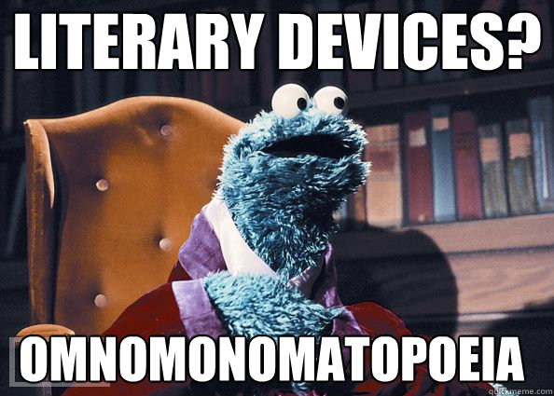

Name:
Watching lectures:
Until 30th April, we have free access to lectures on our texts. The website is :
www.massolit.io
Username: jcs009@jcsonlineresources.org
Password: JCSFoundation
(Free access is available until 31 April.)
Once on, search for both texts and you’ll find a series of lectures on them.
Other lectures that you might find useful are:
https://www.massolit.io/courses/romanticism
https://www.massolit.io/courses/love-through-the-ages
https://www.massolit.io/courses/gothic-literature-8ff4d44e-36ed-4fda-8f6e-2fd53e961f8d
https://www.massolit.io/courses/tragedy-a-complete-history
Remember to make notes as this is only guaranteed to be available until the end of April!

Read “Wuthering Heights” by Emily Bronte and “Othello” by William Shakespeare
Book Reviews
Summarise your opinion of each text: what’s it about? Who would enjoy it? Did you enjoy it?
Wuthering Heights
Your rating:

Wuthering Heights
Summarise 10 key points about the plot of the novel

Look through these 10 key points and summarise the novel in 1 sentence

Now summarise it in to 1 word

Othello
Your rating:

Othello
Summarise 10 key points about the plot of the play

Look through these 10 key points and summarise the play in 1 sentence

Now summarise it in to 1 word

Character analysis
“Wuthering Heights”
Catherine Earnshaw
Heathcliff
Edgar Linton

“Othello”
Othello
Desdemona
Iago

Context
Research 3 different websites and collate information on the following issues (or other relevant context):
- The Victorian Gothic Novel
- Emily Bronte’s life
- Romanticism: the sublime, the Byronic Hero
- Industrial Revolution
WEBSITE LINK:

WEBSITE LINK:

WEBSITE LINK:

Watch a performance of “Othello”:
https://www.rsc.org.uk/news/bbc-culture-in-quarantine has details of performances that will be shown over the coming weeks and months and there’s a version of Othello coming soon!

