Applied Science Bridging Course
Congratulations on choosing to study Applied Science in our Sixth Form. We hope that you really enjoy the subject and your time in our lessons.
To give you an idea of the main topics that you will be studying at the start of your course we would like you to prepare the following material to show that you are prepared to do some work before joining us in September. This work will form part of your Applied Science notes. You will need to research the topics using websites, textbooks and revision guides. If you get stuck then email us at sthomas@stjosephs.uk.net for Biology or twillis@stjosephs.uk.net for Chemistry & Physics.
Please complete your work on separate paper and bring to your first Applied Science lesson in September.
We look forward to meeting and working with you.
Mr S B Thomas Head of Science
Mr T M Willis Head of Biology

Unit 1 Biology
- Draw a large, labelled diagram of an animal cell as seen under an electron microscope. Do not print out a copy from the internet – you need to hand draw it. Your diagram should have the following labels on it:
  - Nucleus
  - Mitochondria
  - Smooth endoplasmic reticulum
  - Rough endoplasmic reticulum
  - Lysosome
  - Golgi body/apparatus
  - Ribosomes
  - Cell surface membrane
- Make a table explaining the function of each of the above structures.
- Show all your working out for the following question:
- Copy & complete the table below to compare prokaryotic & eukaryotic cells:
- Draw labelled diagrams of the following cells & describe & explain how they are adapted for their functions:
  - Palisade mesophyll cell
  - Root hair cell
  - Sperm cell
  - Egg cell
  - Red blood cell
  - White blood cell
- Describe each of these types of tissue: epithelial, endothelial, muscular & nervous.
Unit 1 Chemistry
A copy of the periodic table is found on the next page to help you.
- Draw the electron structures of the first 20 elements in the periodic table using Bohr Theory.
For example here is carbon:
- Research how to write the electron structures of the first 20 elements to show the subshells.
For example here is carbon:
- Create a table like the one below to describe different types of bonding:
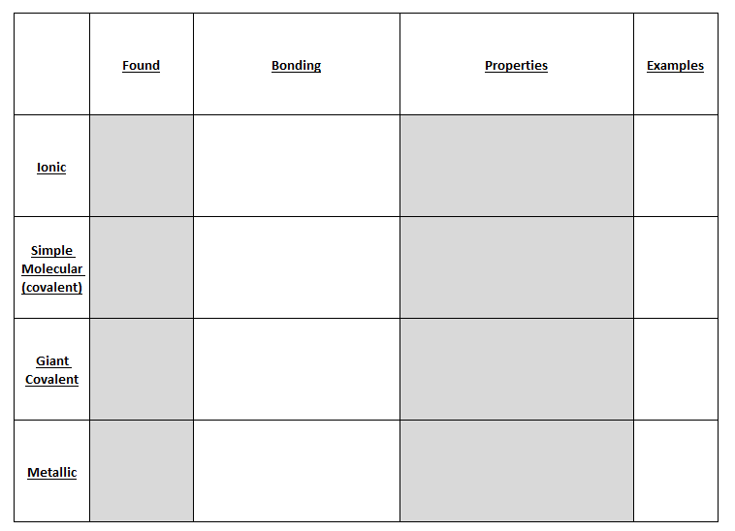
- Draw dot & cross diagrams for the molecules: sodium chloride & carbon dioxide.
- Write balanced symbol equations for the reactions of these elements with oxygen: magnesium, carbon, aluminium & sodium.
- Plot a graph to show the melting points of the first 20 elements:

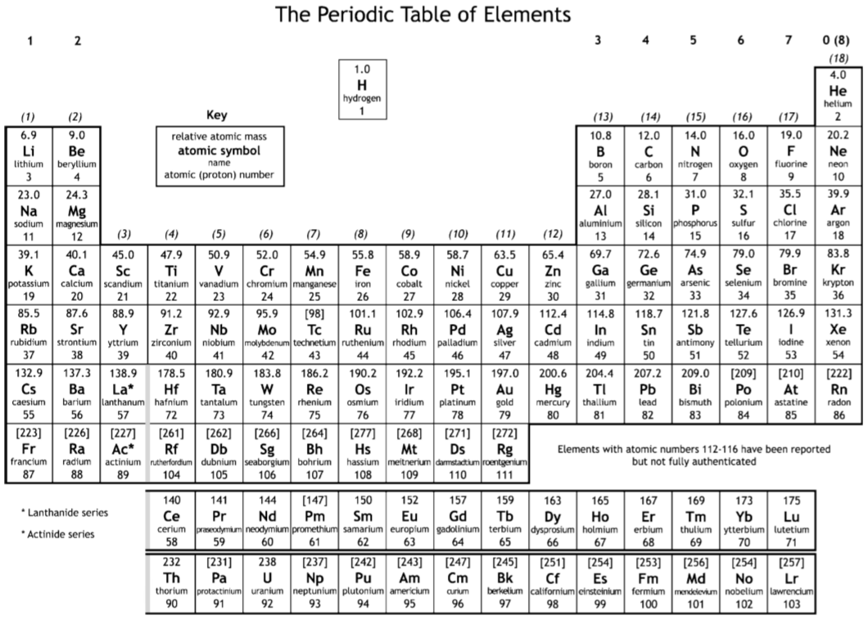

Unit 1 Physics
A copy of the physics equations is found below to help you.
- Draw a transverse & a longitudinal wave.
Label the key features of each wave & describe them.
- Using the correct equation, show all working out to calculate:
  - Wavespeed when the frequency is 50Hz & wavelength is 1.5m.
  - Frequency when wavespeed is 306ms⁻¹ & wavelength is 18m.
  - Wavelength when wavespeed is 14.76ms⁻¹ & frequency is 3.6Hz.
- Describe & explain how to create a standing wave:
- Draw labelled light ray diagrams with a pencil & ruler to show the following:
  - Reflection in a mirror.
  - Refraction as light passes through a rectangular glass block.
  - Total internal reflection in a fibre optic cable.
- Research how an endoscope works & why this is useful in medicine.
- Draw a labelled diagram of the electromagnetic spectrum & describe uses for each part of the spectrum.

