Cambridge Technicals in ICT – Level 3

Bridging Work
Year 11 to 12

Name…………………………………

Unit 1: Fundamentals of IT

UNIT PURPOSE
A sound understanding of IT technologies and practices is essential for IT professionals. Information learnt in this unit will provide a solid foundation in the fundamentals of hardware, networks, software, the ethical use of computers and how business uses IT.

After completing this unit, the knowledge, skills and understanding you have developed will underpin your study for the additional units.

Knowledge gained in the study of this unit will also help prepare you for relevant industry qualifications such as CompTIA A+, CompTIA Mobility+ and Cisco IT Essentials.

TOPIC 1 – “Computer Hardware”

‘What examples of Computer Hardware are there and why are they important?

Input Devices
Research different input devices and complete brainstorm below

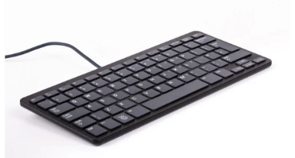
INPUT
DEVICES

Output Devices
Research different output devices and complete brainstorm below

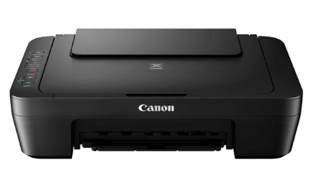

OUTPUT
DEVICES

Communication Devices
Research different communication devices and complete brainstorm below

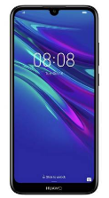

COMMUNICATION
DEVICES

Computer Hardware Uses, Benefits and Limitations
Computer Hardware such as input devices can have a range of uses, benefits and limitations to users or organisations. Carry out some research and complete the tables below.

Provide three for each

Input Devices
Use | Benefit | Limitation
1. | 1. | 1.
2. | 2. | 2.
3. | 3. | 3.

Output Devices
Use | Benefit | Limitation
1. | 1. | 1.
2. | 2. | 2.
3. | 3. | 3.

Communication Devices
Use | Benefit | Limitation
1. | 1. | 1.
2. | 2. | 2.
3. | 3. | 3.

TOPIC 2 – “Computer Components”

‘Describe the role of different computer components’

Computers have different components to enable to the computer to function correctly. Each component has a different role or function. Carry out some research to find the role of different computer components
Complete the table below:
The first one has been done for you…
Component | Image | Role
Processor | 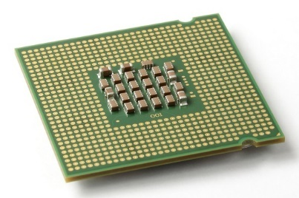 | - The CPU or Central Processing Unit is the main chip in a computer responsible for carrying out all tasks.  - It's responsible for telling all the other components in a computer what to do, according to the instructions it is given by the programs (software) running on that computer
Motherboard
Hard Drive
USB Port
RAM
ROM
Graphics Card

TOPIC 3 – “Types of Computer System”

‘Explain the uses of different types of computer system’
There are different types of computer system e.g. a server. They have different uses and can be used for different scenarios and examples
Carry out some research on computer systems and complete the table below
System | Use/Role | Scenario/Example
Desktop
Tablet
Server
Smart Phone
Embedded System
Mainframe

TOPIC 4 – “Connectivity Methods”

‘Describe the characteristics of different connectivity methods’
There are different types of connectivity methods that can be used e.g. Bluetooth. Each method is used for the main role of connectivity and communication. However, some may have different characteristics or attributers
For example, Bluetooth is wireless but can only be used over short distances…
Carry out research on different connectivity methods characteristics and complete the table below:
Connectivity Method | Image | Characteristics
Copper Cable | 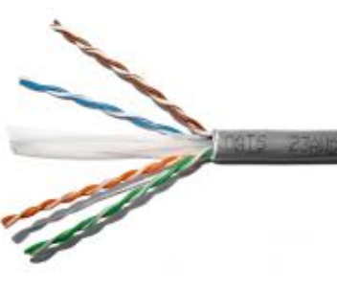
Fibre Optic | 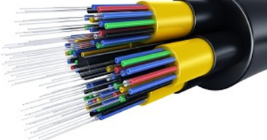
Bluetooth | 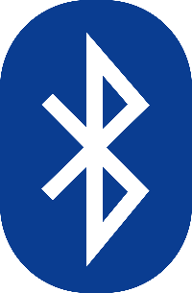
Wi-Fi
Infrared
Satellite | 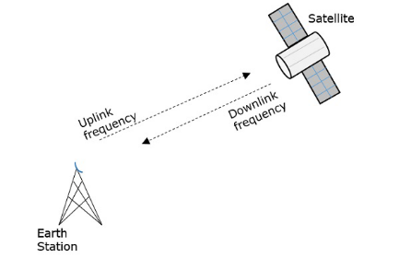
3G/4G/5G | 