Planning on starting A level Philosophy and Ethics next year?

Here are some activities and things to think about, to get you started. Read over and try to complete all the suggested activities, but you can focus more on the one(s) that interest you most:

Activity 1

Scenario: I’m on school lunch duty and I see and hear a girl saying nasty things to another girl while they’re eating their shepherd’s pie.

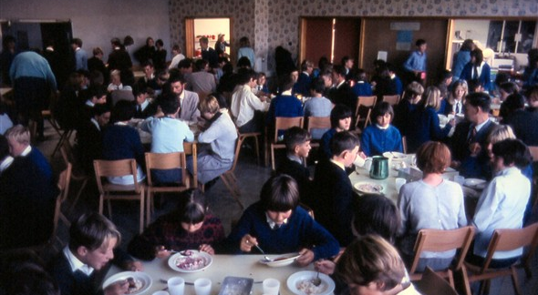

Questions:
Why is it OK, and my duty, to tell her off for being unkind?
Why is it not OK for me to tell her off for eating meat (I’m vegetarian)?

And then:

Which, if any, of our beliefs are ‘just a matter of personal preference’ and which, if any, refer to some kind of absolute fact?

Should we leave others to their ‘personal preference’ in matters of religious belief, or are some religious beliefs right and others wrong in an absolute sense?

Is there an ultimate truth, an absolute right and wrong, about religious truth claims?

At what point, if any, does one culture have the right to tell another ‘you’re doing it wrong’ over matters of religion and ethics?

To what extent, if at all, do people have an obligation to share their religious faith with others – or should we keep our beliefs to ourselves and try and respect the views of others even if we think they’ll miss out on going to heaven?

Activity 2

‘Visit’ the British museum online

https://britishmuseum.withgoogle.com

Explore the collections at the Horniman Museum

https://www.horniman.ac.uk/collections/explore-our-collections

… and any other museums you can find online.

Questions:

How much can we tell about people’s beliefs, from the objects they leave behind?

What makes an object a ‘religious’ object, rather than just a special one?

Why do religious people have sacred objects – what function do they serve?

Become a geek about one of the objects that takes your interest – find out more about the culture it comes from, what the people believed and how the object was used, as well as which questions remain unanswered.

Activity 3

Watch this documentary, ‘Barra Boy’

https://www.youtube.com/watch?v=nhGX1YCsvAM

Do you think the story provides convincing evidence for reincarnation? Why, or why not?

What do you think counts as ‘convincing evidence’ for life after death (e.g. scripture, near death experiences, nothing)? What makes evidence convincing or unconvincing?

Read the accounts in the gospels of the resurrection of Jesus (you could use biblegateway.com)

Matthew 28:1 – 10

Mark 16: 1 – 8

Luke 24: 1 – 10

John 20: 1 – 18

Do you find these stories convincing? Why, or why not?

Do you think the stories contradict each other, or are they just told from different points of view, in your opinion? What might account for the differences and the similarities between the stories?

Activity 4

Get to know some of the philosophers you will meet during your A level course

https://www.bbc.co.uk/programmes/p01f0vzr

(They are quite long and heavyweight, don’t worry if this activity isn’t for you)

Practice your note-making skills by pausing and writing a summary of what you’ve heard so far. Think about whether you agree with what the philosopher is saying.

Listen to whatever takes your interest. For Philosophy and Ethics, you could concentrate on the ones starred, or others from this list:

Plato’s Republic ** St Thomas Aquinas

**St Augustine The Ontological Argument

** The Soul **Redemption

**Kant **Relativism

**Utilitarianism William James

**David Hume Nietzsche

Al-Ghazali **Duty

**Good and Evil

Logical Positivism **John Stuart Mill

Altruism **Feminism

**Evil Empiricism

