_{Introduction to}
A-Level
Sociology

Name: ____________________

Dear Sixth Form student,

Welcome to the Sociology department at St Joseph’s. Sociology is an excellent choice of subject to study at A-Level and one that you will find exciting, interesting and very relevant to your everyday life.
The topics you will be studying in Year 12 are ‘Families and Households’ and ‘Education’. These are areas you already know a lot about, so you should get off to a flying start in September even if you have not studied Sociology before.
This booklet has been put together to make sure you are fully prepared for the important year that lies ahead of you. There are four activities in total. Work your way through them and bring the booklet along with you to your first lesson.
See you in September!

Mrs Rogan

Head of Sociology
roganz@stjosephs.uk.net

_{Activity 1}
A general introduction to Sociology and the key terms we will be using next year

Instructions:

- Read the information on the next few pages.

- Complete the glossary sheet that follows.

- These are the key terms that you will be using during the course of your A Level studies. Write each definition in your own words to help you understand what each term means.

- Try to remember as many of these key terms as possible.

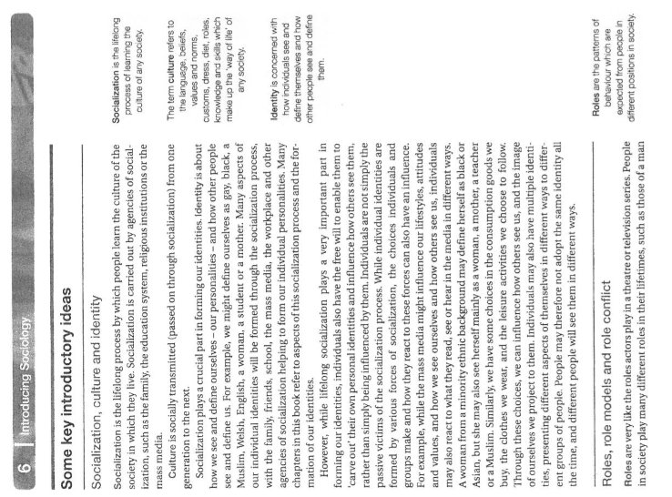

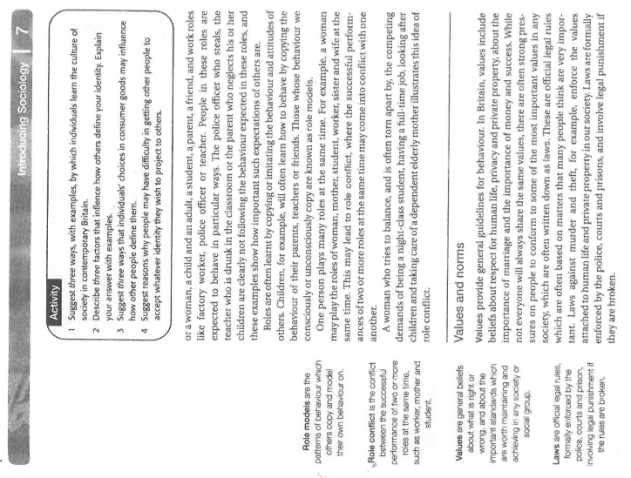

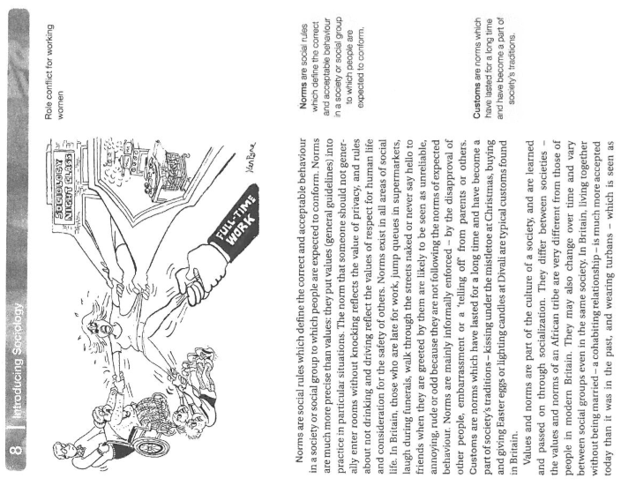

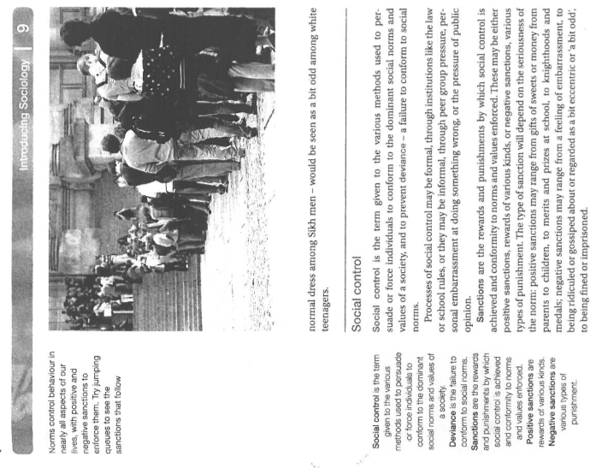

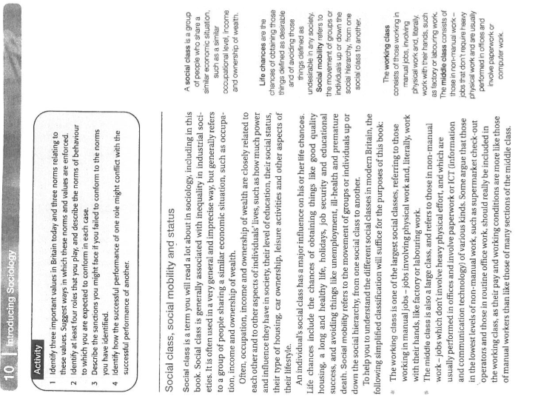

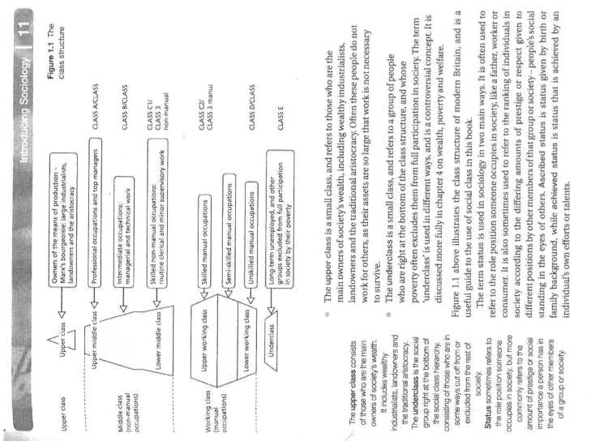

Activity 1
Glossary of Key Sociological Terms

Social Institutions

Social Structure

Socialisation

Primary
Socialisation

Secondary Socialisation

Culture

Values

Norms

Social Control

Social Class

Working Class

Middle Class

Upper Class

Social Mobility

_{Activity 2}
An Introduction to Unit 1: Families and Households

Instructions:

- Answer the questions using the information available in the ‘Item’ provided.

- Where the question does not refer to the ‘Item’ try to use your own knowledge and experience to answer it

- If you are unsure of how to answer any of the questions that require your own knowledge, think about the question logically. For example, question 3 – there could be a rise in people living alone because people are now getting married later in life or because there is an ageing population

- Write the answers in the spaces available

Unit 1: Families and Households

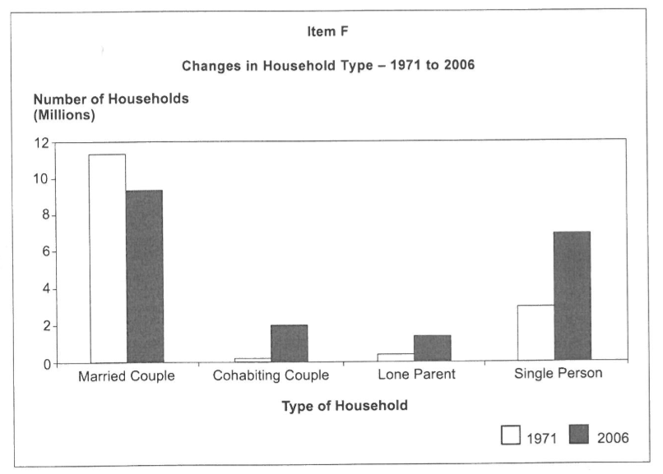

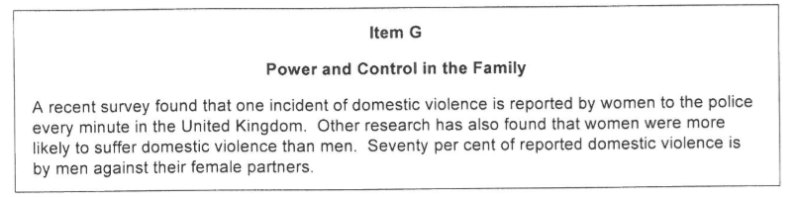

- From Item F, were there more lone parent households in 1971 or in 2006?

- From Item G, identify how often an incident of domestic violence is reported to the police by a woman?

- Identify two reasons for the rise in single person households from 1971 – 2006 (this is one of the questions you will have to use your own knowledge to answer)

- What is an extended family?

- Describe one way a grandparent might provide for a family and explain how this would help the family

- Describe one way that the government might provide help for lone parent families and explain how this would assist them

_{Activity 3}
An Introduction to Unit 2:
Education

Instructions:

- Answer the questions using the information available in the ‘Item’ provided.

- Where the question does not refer to the ‘Item’ try to use your own knowledge and experience to answer it

- If you are unsure of how to answer any of the questions that require your own knowledge, think about the question logically.

- Write the answers in the spaces available

Unit 2: Education

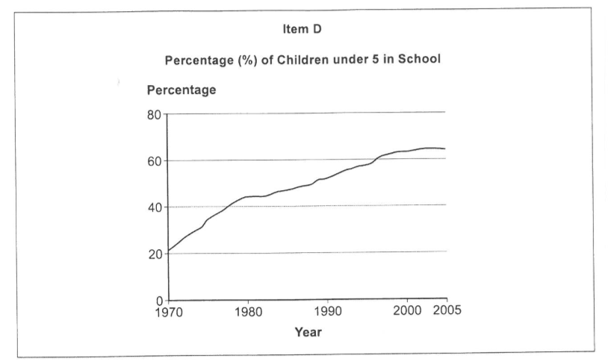

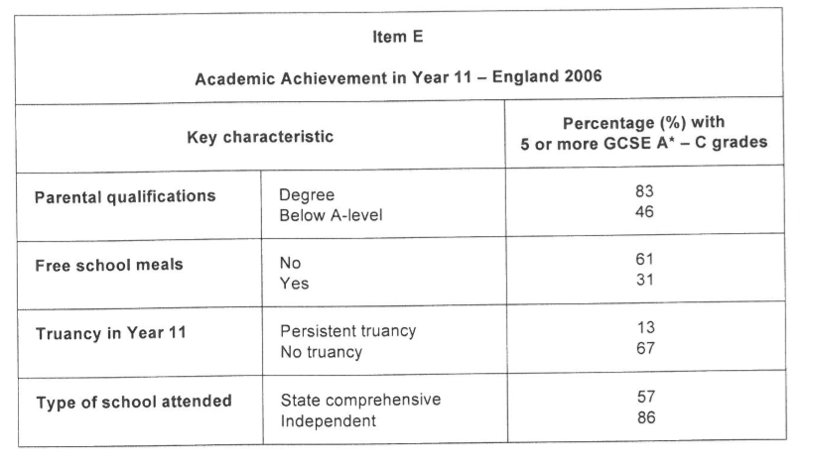

- From Item D, what is the overall trend between 1970 and 2005 in children under 5 attending schools?

- From Item E, what percentage of children who receive free school meals obtained 5 or more A* - C grades at GCSE?

- Identify two reasons why parents may or may not wish to send their children to a particular school

- Explain what is meant by the term curriculum

- Identify one way parents can help their children do well at school and explain how it could help

- Identify one way the government can check what happens in schools and explain what effect this type of monitoring might have on the school

_{Activity 4}

How would you take charge in a world wide pandemic?

Instructions:

- Imagine you are the Prime Minister of the United Kingdom and you need to protect the country from a world-wide pandemic that threatens life as we know it. The only way to do this is to stop everyone living their normal, everyday lives.

- Your task is to plan how you would protect everyone and stop the spread, with particular reference to the issues on the next few pages

- Think carefully about each issue raised and jot a few ideas in the space below

- Remember – your ideas about how to tackle each issue need to be in line with the aims and beliefs that you say should be important in your society. For example, you can’t say that it is important that your society is fair and equal and then say the richest people get the biggest share of the food and resources.

How Would You Respond in a World-Wide Pandemic?

- What were the aims and beliefs of your society before this pandemic?

- How will you make sure these aims and beliefs are maintained?

- Who do you protect first? Which group/groups of people are your priority? Why?

- When measures are introduced to minimise the threat of the pandemic how do you ensure everyone knows about them and follows the new rules?

- How do you think people will respond to this new way of living?

- How would you deal with the people who broke the rules?

- How are you going to make sure that vulnerable groups e.g. children and old people are properly cared for?

- How would you make sure food and other things necessary for survival are produced?

- How do you ensure everyone gets what they need to survive?

