St. Wilfrid’s RC College

BTEC Level 3
Nationals in Sport

Year 11 to Year 12 Bridging Unit

Unit 2
Fitness, Training and Programming for Health, Sport and Well-Being
(Examination Unit)

Exercise and Physical Activity
Research Task – Can you find out the government guidelines for physical activity?

Can you name three benefits under each subheading of an individual participating in physical activity?
Physical | Psychological | Social | Economical

Diet
Research the following definitions.
Diet –

Balanced Diet –

Malnutrition –

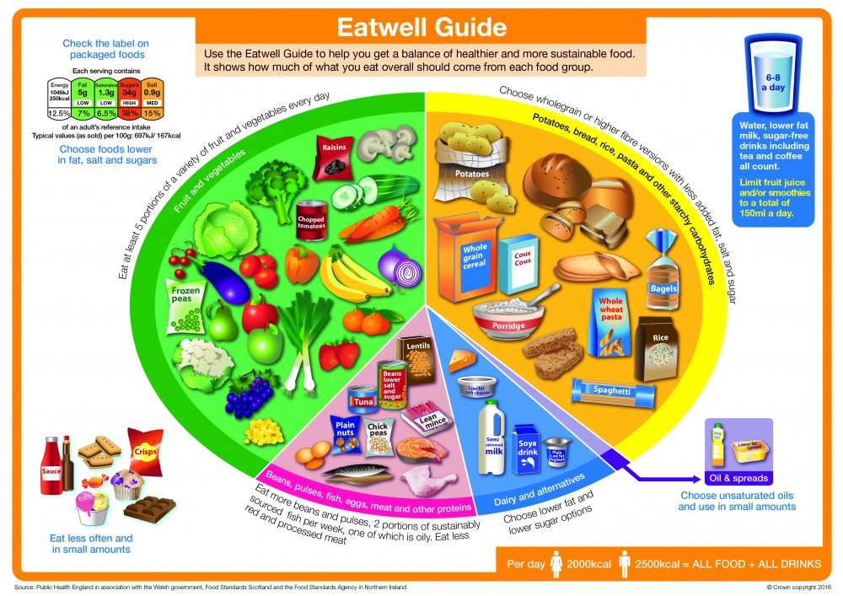
In the table below…
- In the first row, discuss the type of diet an individual would consume to obtain these benefits.
  - Use the Eatwell Guide above to help you!

- In the second row, discuss…
- Which chronic diseases does a healthy diet reduce your risk of developing?
- How does a healthy balanced diet improve immune function?
- How does a healthy balanced diet help maintain a healthy body weight?
Reduced risk of chronic disease | Improved immune function | Maintaining a healthy body weight

Smoking
Tobacco smoke contains nicotine and tar which are both damaging to our health.
How are they detrimental to a person’s health?
Nicotine –

Tar –

How does smoking cause the following health risks?
Cancer | Bronchitis | Coronary Heart Disease | Lung Disease | Infertility

Alcohol
Research the following definitions.
Scar Tissue –

Malnutrition –

Difference between systolic and diastolic blood pressure –

How does smoking cause the following health risks?
Stroke | Cirrhosis of the Liver | Hypertension | Depression

Exam Technique
Using the information below, taken from a Unit 2 past paper, you should now attempt to write four paragraphs, one paragraph for each of the topics you have worked on…
- Exercise and Physical Activity
- Diet
- Smoking
- Alcohol

For each of the following topics, you should attempt to answer the following questions which will structure your paragraphs…
- Is this factor good or bad?
- Compare the factor to government guidelines?
- Justify whether it is good or bad using knowledge and theory?

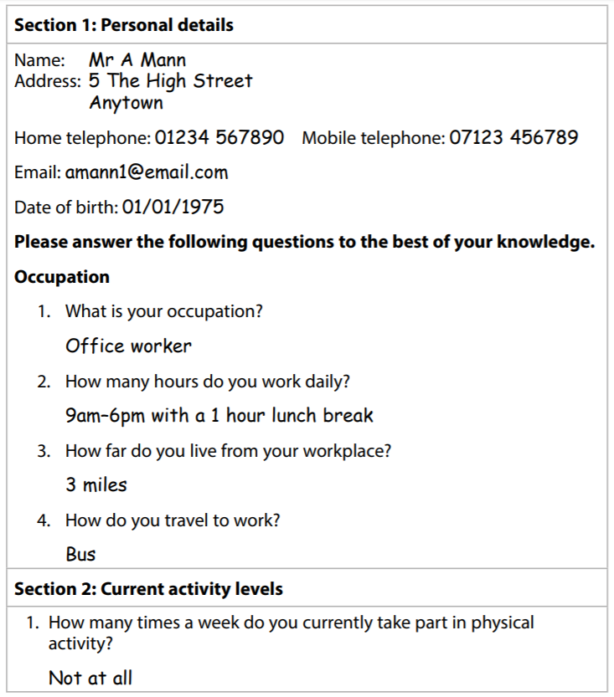

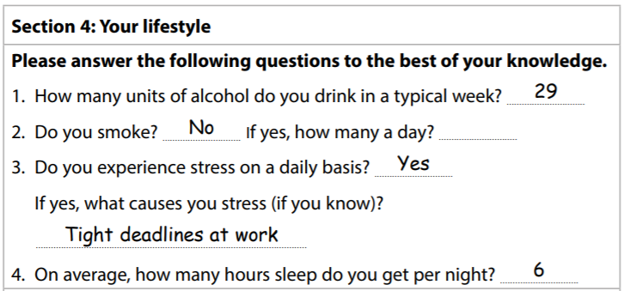
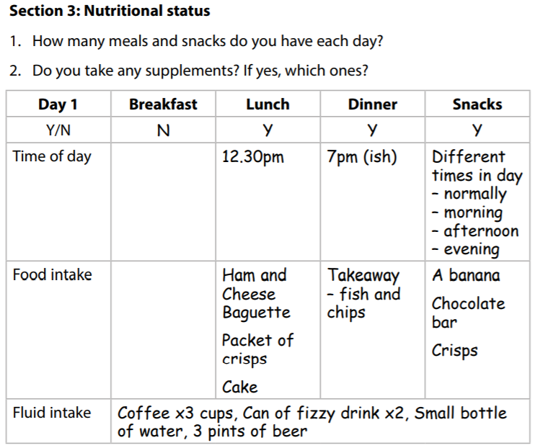
Paragraph 2 – Diet
Paragraph 1 – Exercise and Physical Activity
Paragraph 4 – Alcohol
Paragraph 3 – Smoking

Unit 3
Professional Development in the Sports Industry
(Coursework Unit)

Learning Aim A
Understand the Career and Job Opportunities in the Sports Industry

Task 1 – Research the vast range of jobs in the sports industry (from PE teachers to Physiotherapists). Compile a list of as many sporting industry jobs as you can find.

Task 2 – Choose TWO potential contrasting careers in the sporting industry (i.e. PE teachers and sports coaches would be too similar!) that you are really interested in.
For each career, research the bullet points below and make notes under each one.
Career 1
- Are there a large number of jobs available in that area?

- Geographical – Are there jobs close by or would you need to travel?

- Financial – What is the standard pay for that job? Are there opportunities for promotion within this career? If so, what promotions?

- What qualifications/certificates and experiences do you need to do that job?
  - (i.e. PE Teacher – a sporting BTEC/A level, Degree in Sport, Qualified Teacher Status, DBS to allow you to work with young people, coaching qualifications in a range of sports, as a minimum)

Task 2 – Continued

Career 2
- Are there a large number of jobs available in that area?

- Geographical – Are there jobs close by or would you need to travel?

- Financial – What is the standard pay for that job? Are there opportunities for promotion within this career? If so, what promotions?

- What qualifications/certificates and experiences do you need to do that job?
  - (i.e. PE Teacher – a sporting BTEC/A level, Degree in Sport, Qualified Teacher Status, DBS to allow you to work with young people, coaching qualifications in a range of sports, as a minimum)

Unit 5
Application of Fitness Testing
(Coursework Unit)

Learning Aim A
Understand the Principles of Fitness Testing
Learning Aim B
Explore Fitness Tests for Different Components of Fitness

Task 1 – Research fitness testing in sport and why standard procedures are so important to testing. Create a list of key components which would ensure that all tests undertaken are valid, reliable, practical and follow ethical requirements.

Task 2 – Choose TWO fitness tests from the list below.
Physical Fitness Tests
- Flexibility
  - Sit and Reach
  - Shoulder Flex
  - Calf Muscle Flexibility
  - Trunk Rotation
- Strength
  - 1RM
  - Grip Dynamometer
  - Seven Stage Abdominal Strength
- Aerobic Endurance
  - Multi Stage Fitness
  - Maximal Oxygen Consumption (VO₂ max)
  - Twelve Minute Cooper
  - Harvard Step
  - Rockport Walk
- Speed
  - Sprint – 20 metres, 30 metres, 40 metres, 50 metres, 60 metres.
- Muscular Endurance
  - One Minute Press Up
  - One Minute Sit Ups
  - Wall Sit
- Body Composition
  - Skinfold
  - Bioelectrical Impedance Analysis
  - Body Mass Index (BMI)

Skill-Related Fitness Tests
- Agility
  - Illinois Agility Run
  - T-Test
  - Side-Step
- Balance
  - Stork Stand
  - Beam Walk.
- Co-Ordination
  - Wall-Toss
- Power
  - Vertical Jump
  - Standing Long Jump
  - Margaria Kalamen Power
  - Seated Medicine Ball Throw
  - Cricket Ball Throw
  - Wingate
- Reaction Time
  - Ruler Drop

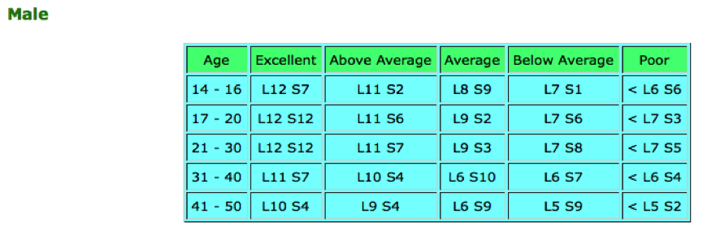
Once your two tests have been chosen, if possible practically complete the tests and record data to compare against normative data for that test. If unable to undertake the test, choose data taken from two normative data tables… example below for males the Multi Stage Fitness Test.

For each test chosen RAG (Red, Amber, Green) rate them and complete a few paragraphs on how you may improve or maintain performance over a four week period if we were to complete the same tests again.
Use specific related training methods to help support this.

Test 1
Test 2

