**College Taster Day for Year 11 Students: Wednesday 1st December 2021**

Dear Parent / Guardian

We are offering your son / daughter an exciting opportunity to attend a taster day at South Tyneside College on ***Wednesday 1st December***. The purpose of this day is to allow students to experience what courses are on offer and to support them in making decisions for their future pathway beyond Year 11. Your son/ daughter has been given the opportunity to experience vocational courses and will spend the day at South Tyneside College exploring the different options there. Your son/daughter will be selecting their subject choices on Wednesday 17th November. Information about each of the subject choices on offer can be found on the option choice form below or on South Tyneside college website:  [Courses | South Tyneside College (stc.ac.uk)](https://www.stc.ac.uk/courses-by-interest/44).

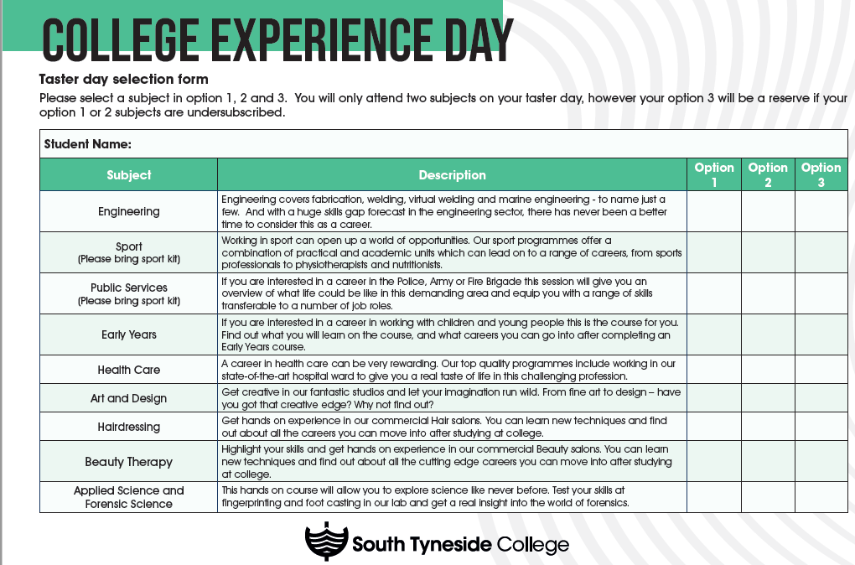

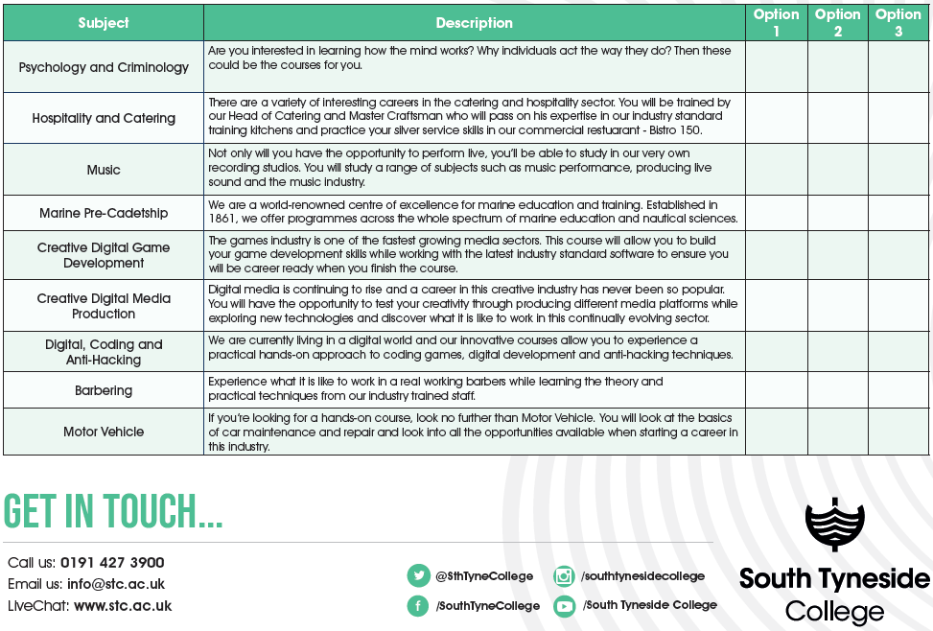

Students who are attending South Tyneside College will need to wear sensible clothing and footwear for their sessions (e.g. sports students will need trainers and comfortable clothes / engineering should bring sensible footwear etc.). Students have chosen the options that they want to explore at the college.

Students will be expected to arrive into school as usual for 8.45am will be transported by coach from St Wilfrid’s R.C College at 8.50am and will arrive back to St Wilfrid’s via coach at 3.10pm. Students will be dismissed from St Wilfrid’s and are not permitted to make their own way home from the college.

The college will be providing a packed lunch for all students, but they may wish to take a small amount of money to purchase any additional drinks or snacks from the college refectory.

Could I please ask you to complete the consent form below and the attached medical form and return to school by **Friday 19th November**. If you have any queries or concerns regarding this, please do not hesitate to contact me.

Yours faithfully,

*Mrs K Forster*

**Assistant Headteacher – Lead for Sixth Form**

________________________________________________________________________________

I give permission for my son/daughter to take part in the College Taster Day on 1st December 2021

Pupil Name:__________________________________________________________

Parent/Guardian Signature:_______________________________________________________

Medical Information: _____________________________________________________________

Dietary Requirements: _____________________________________________________________

Emergency Contact Name: ___________________________________________________________

Emergency Contact telephone number: _________________________________________________