Year 11 Sixth Form Taster Day
Wednesday 1st December 2021

Your child will be given the opportunity to experience what sixth form life is like at St Wilfrid’s by attending sixth form lessons and tutorials on Wednesday 1st December. Sixth form dress code should be followed, but please note there is no expectation to purchase anything new for this day. I have outlined the sixth form dress code expectations below, but students are welcome to wear their usual school uniform if they prefer.

The dress code is based on smart, business like attire.
Clothing
- Black or grey smart, dress trousers / knee length skirt / dress (no tight ‘Body Con’ / Lycra / stretch type material)
- Single colour V - Neck jumper or cardigan (optional)
- Shirt / blouse– single colour of own choosing
- Tie – single colour or patterned, of own choosing - no pictures or graphics
- Smart black shoes (Not trainers or plimsolls)
- Jacket – of own choosing (no denim or hoodies)
- Subtle make-up may be worn – no heavy mascara, blusher or lipstick.
Jewellery
- A watch
- A ring
- One pair of stud earrings
- No facial jewellery allowed

Students will select their options from each of the following option blocks on Wednesday 17th November. They will follow the usual school day timings, they should attend their morning registration class as usual. Students will experience four different subject options on this day and will also attend a tutorial session to prepare them for higher education. Further information about each of the subjects on offer at Sixth Form can be found: Key Stage 5 Subjects - St. Wilfrid's R.C. College (st-wilfrids.org)

The subject options are as follows:
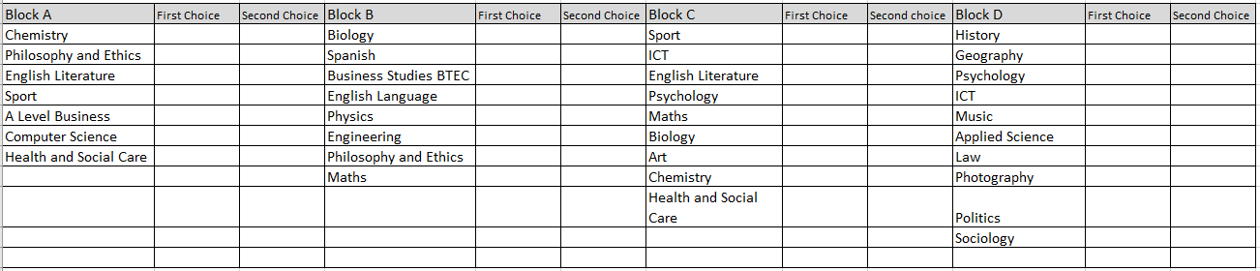

We are looking forward to showcasing our wonderful sixth form subjects and we hope your child finds the day informative.

Kind regards

Mrs K Forster
Assistant Headteacher – Lead for Sixth Form

