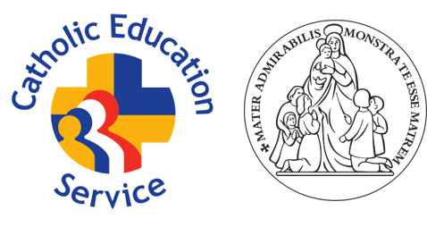
CES NATIONAL STANDARDS FOR CHAPLAINS
WORKING IN SCHOOLS AND ACADEMIES
National Standards for Chaplains working in schools and academies are divided into five key areas:

- The Chaplain as witness
- The Chaplain as pastor
- The Chaplain as leader
- The Chaplain as educator
- The Chaplain as professional

The Chaplain as witness
The Chaplain should:
- be a practising Catholic in full communion with the Church;
- set a good example to all members of the school community in terms of living a Christian life by:
  - being a person who prays and makes prayer an important feature of decision making and who intercedes on behalf of the community they serve;
  - speaking of their own faith and relationship with Christ;
  - living a life which exemplifies Gospel values;
  - treating all members of the community with dignity, building relationships rooted in mutual respect, and at all times observing proper boundaries appropriate to the chaplain’s professional position;
  - showing tolerance of and respect for the rights of others;
  - demonstrating a commitment to Catholic Moral and Social Teaching.

The Chaplain as pastor
The Chaplain should:
- be attentive to the needs of all members of the school community
- support other staff in school who share the responsibility of the pastoral care of pupils, including the Head Teacher;
- accompany the whole community in their highs and lows, celebrating with them in their joys and consoling them in their sorrows;
- be able to relate to a wide range of individuals and establish levels of trust where problems can be shared;
- focus on the marginalized and the vulnerable within the school community as their special care.

The Chaplain as leader
The Chaplain should:
- have a good understanding of the liturgical life of the Church and be able to lead pupils and staff into a fuller appreciation of its richness and beauty;
- know how to prepare a space for prayer;
- have the skills of a well-trained sacristan and know how to both prepare a space for the celebration of Mass;
- care for any sacred space in school, especially where the Blessed Sacrament is reserved;
- be skilled in engaging children and young people in prayer, worship and the sacramental life of the Church, particularly the Eucharist and the sacrament of reconciliation, where appropriate;
- support class and whole school based worship through the provision and creation of appropriate worship resources;
- help pupils and staff to develop confidence in leading prayer and worship independently;
- provide opportunities for staff and pupils to deepen their spiritual life, for example, through the organizing of retreats and days of reflection.

The Chaplain as educator
The Chaplain should:
- have a good knowledge and understanding of the Catholic faith to:
  - support school catechetical programmes (where they exist);
  - support the formal and informal learning that takes place across school life;
- ensure that structured time with pupils is well-planned, delivered and evaluated;
- support the professional development of staff in terms of the Catholic life of the school.

The Chaplain as professional
The Chaplain should:
- if a priest, celebrate Mass and the sacrament of reconciliation regularly in school;
- if not a priest, make arrangements for the regular celebration of Mass and the sacrament of reconciliation within school with the priest(s) of the local parish or deanery;
- form good working relationships with the nearby priest(s) and parishes and facilitate partnership working between parish/deanery/diocese and school.
- maintain good working relationships with other members of staff, governors/directors and school leaders;
- observe professional standards in terms of appearance, punctuality and full participation in the working life of the school;
- have regular performance appraisal;
- have regard for the need to safeguard pupils’ well-being, in accordance with statutory provisions;
- Contribute to self-evaluation processes in readiness for inspection.

