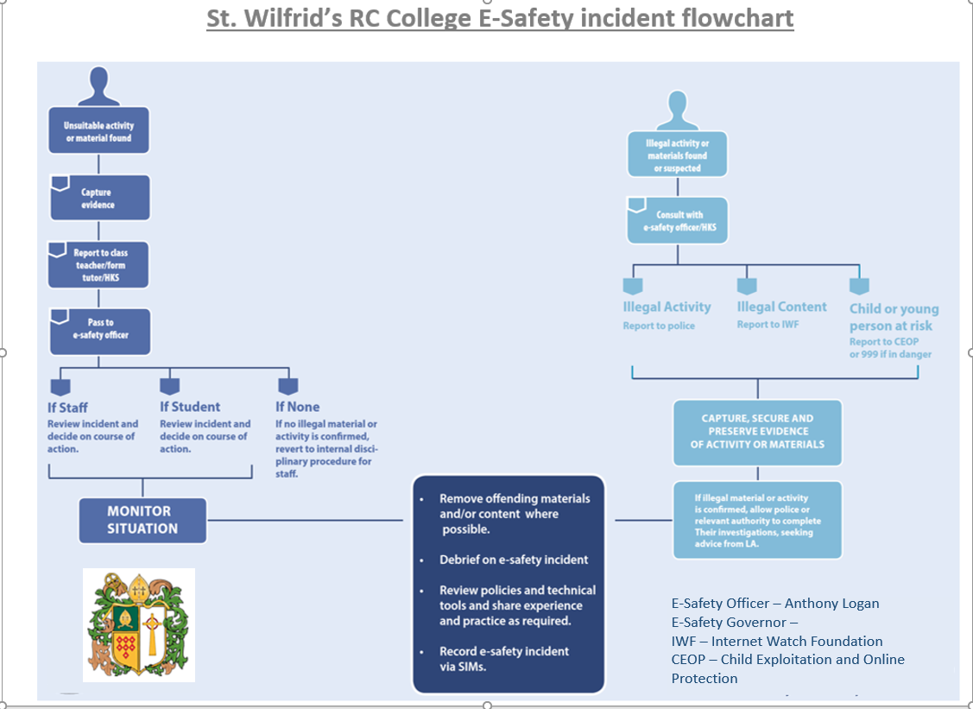

E- Safety Officer – Anthony Logan

E-Safety Governor – Anthony Skipper

IWF – Internet Watch Foundation

CEOP – Child Exploitation and Online Protection