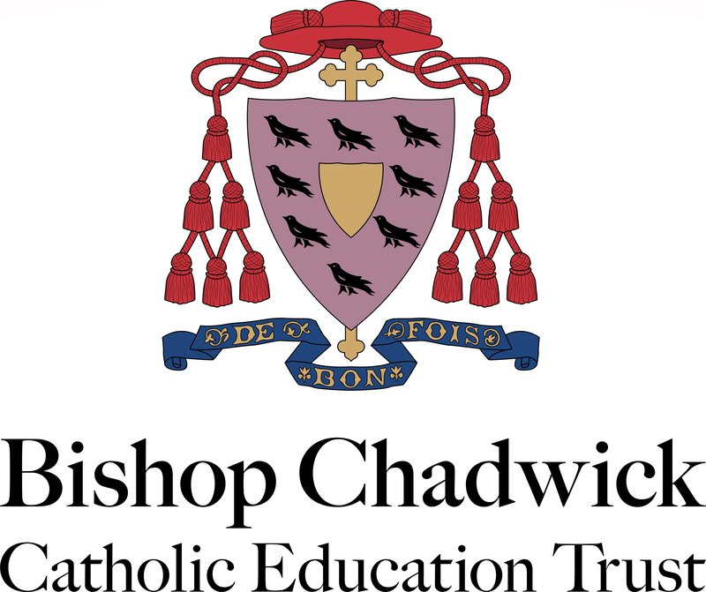

Modern Slavery Statement

Statement Dated / Reviewed: | March 2022
Adopted / Reviewed by Directors: | March 2022
Date of Next Review: | February 2023

1.0 Introduction
1.1 Modern Slavery is a crime and a violation of fundamental human rights. It takes various forms, such as slavery, servitude, forced and compulsory labour and human trafficking, all of which have in common the deprivation of a person’s liberty by another in order to exploit them for personal or commercial gain.
The Trust is committed to acting ethically and with integrity and transparency. The statement is made in relation to section 54 of the Modern Slavery Act 2015 and sets out the Trust’s aims and commitments to ensure that modern slavery and human trafficking are not taking place in our own operations or it’s supply chain.

2.0 Scope
This policy applies to all Directors, Governors and employees working on or behalf of the Trust, including agency workers, volunteers and contractors.

3.0 Policies in relation to to Modern Slavery and Human Trafficking
3.1 The Trust has a number of policies in place to ensure that our business is conducted in an ethical manner, these include:
- Recruitment Policy
- Whistleblowing Policy
- Code of Conduct
- Finance Policy
- Complaints Policy
3.2 The Trust follows a safer recruitment process in line with Keeping Children Safe in Education. As part of the recruitment process, vetting checks are undertaken including proof of right to work in the UK.
3.3 The Trust annually reviews the pay policy and associated pay scales in line with national minimum wage requirements.
4.0 Risk Assessment and Management
4.1 The Trust has formally identified and documented the major risks to which Bishop Chadwick is exposed. The risks are reviewed by the Directors, Audit Committee, Executive Team and Central Team regularly. Risk management strategies have been implemented to ensure risk management is embedded in our day-to day procedures.
4.2 The Trust have procured internal auditors to undertake a programme of internal testing on systems, controls and adherence to policy and procedures. Any non-compliances are included in the internal audit reports, which are communicated to the Audit Committee, Executive Team, Central Team and business staff.
4.3 The Trust employs a dedicated procurement professional to lead on commercial activity.

5.0 Structure and supply chains
5.1 The Trust employs a dedicated procurement professional to lead on commercial activity, supported by Central Team. The use of existing approved frameworks is encouraged for all tendering activity. This reduces the risk of partnering with businesses who do not have secured supply chains.
5.2 Contract management meetings are in place to monitor activity and discuss any concerns.

6.0 Due Diligence processes
6.1 Upon schools converting to become and an academy and join the Trust a full and thorough due diligence procedure is undertaken, this includes a review of contracts and service level agreements.

7.0 Effective action to address modern slavery
7.1 The Trust will share this statement with all employees and raise awareness.
7.2 This acadmic year, the Trust will review its supply chain and ensure compliance. This will include the gathering information relating to modern slavery and human trafficking from current and new suppliers.

Signed

Mr D O’Mahoney Mr T B Tapping
Chair of Directors CEO

