St Wilfrid’s History Y12 Bridging Unit: Russia
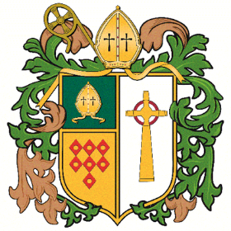

To help you gain a bit of background knowledge about Russia before 1917, complete the following activities.
Task 1: Reading and annotating reading texts
- Read the text that you have been given – Corin p.2-23
- Underline the key points and annotate them with your thoughts about what this tells you about Russia
- Watch Lucy Worsley’s Empire of the Tsars: Episode 3 (on BBC iPlayer)
Task 2: What were the long term problems in Russia before 1914?
Pg. Corin 4-8
Complete the worksheet where you explain how each of the different sub-headings created problems in Tsarist Russia. Ensure that you use 2-3 bits of SPED evidence and explain in depth.

Optional stretch: Independent reading about Russia 1905-1917
- http://spartacus-educational.com/RussiaIssues.htm
- http://spartacus-educational.com/RussiaEvents.htm

