A Level Business
Bridging Unit
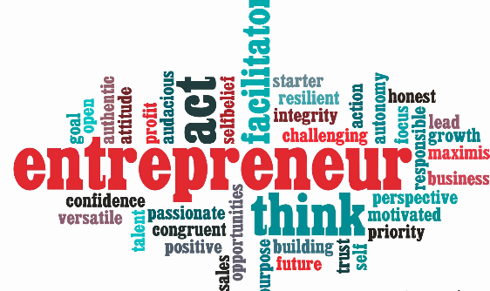

Year 12 – 13

Task 1:
A3 Revision Sheets

Ensure that you have completed all of the A3 revision sheets you were given before the school closure.
You should then make a note of any topics from Theme 1 or 2 that you fell you would benefit from revisiting in September.

You should choose two from each theme;

Task 2: Planning for a new Enterprise
A successful entrepreneur needs to understand the market, have determination, passion, and resilience and be able to take and cope with risk.
Outline A New Social Enterprise Business Idea you could possibly start: Think of the type of business e.g. sole trader, concept, purpose and suitable name. If you entered the competition then you can use this idea.

How would you plan to expand in the future?

Any other ideas to note?

What would your sources of finance be?

How would you research the market?

Task 3: Extended Writing

Blue Challenge
Explain one advantage to an entrepreneur of your choice of being able to take risks. (4)

Purple Challenge
Assess two of the most important characteristics of an entrepreneur.
Pink Challenge (8)

Pink Challenge
Thinking about your new enterprise idea in task 2, evaluate the benefits and drawbacks to you personally of starting that business. (20)

__________________________________________________________________________________________________________________________________________________________________________________________________________________________________________________________________________________________________________________________________________________________________________________________________________________________________________________________________________________________________________________________________________________________________________________________________________________________________________________________________________________________________________________________________________________________________________________________________________________________________________________________________________________________________________

____________________________________________________________________________________________________________________________________________________________________________________________________________________________________________________________________________________________________________________________________________________________________________________________________________________________________________________________________________________________________________________________________________________________________________________________________________________________________________________________________________________________________________________________________________________________________________________________________________________________________________________________

Task 4: Barriers to entrepreneurship.
One barrier to entrepreneurship is lack of finance. Carry out research and find more examples of barriers. Present your findings in a though shower below.

Barriers
To
Enterprise

Task 5: Entrepreneur motives

Entrepreneur motives can be broken down into financial and non-financial motives.
Complete the table below to show a range of both types of motives. The first one has been done for you.

Financial Motives | Non-financial Motives
Profit maximisation | Independence

Task 6: Types of Ownership
Complete the table below to show examples of ownership types and their relevant advantages and disadvantages to the business.
Type of Business | An example | Advantages | Disadvantages
Sole Trader

Partnership

Private Limited Company

Public Limited Company

Franchise

Social Enterprise

