St. Wilfrid’s RC College
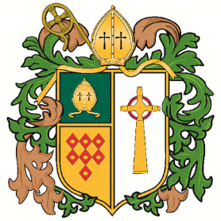

Bridging Unit
A Level
GCSE

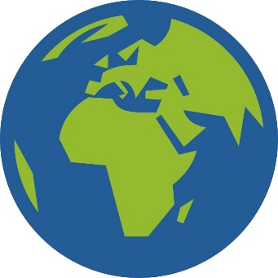

Geography Department

Skill 1- Multiple Geographies
In geography you need to ensure you have a balanced approach, always looking at both sides of the argument. To do this you are going to need to extend your knowledge by reading and watching.
Task 1-Simon Reeve is an excellent geographer and brings exciting issues to us. There are lots of his tv programmes you can watch...in fact it is extremely hard to pick which episodes to watch! (Type into Google “Simon Reeve”) If you have time they are all good to watch!! However, we have picked 3 episodes which we think are the best.
We would like you to pick ONE episode and complete the table below.
Issue | Cause | Effect | Response

The Americas with Simon Reeve
In this episode you will learn about some of the threats to our water supplies.
https://www.bbc.co.uk/iplayer/episode/m0009tvs/the-americas-with-simon-reeve-series-1- episode-3
Australia with Simon Reeve
In this episode you will learn about the impacts that people are having on the environment of Australia with a look at the Great Barrier Reef.
https://www.bbc.co.uk/iplayer/episode/b021ncc4/australia-with-simon-reeve-episode-2
Mediterranean with Simon Reeve.
In this episode you will look at the movement of refugees meeting some of the people prepared to risk their lives making the perilous journey from their homeland to get to Europe.
https://www.bbc.co.uk/iplayer/episode/b0bqn4g1/mediterranean-with-simon-reeve-series-1- episode-4

Task 2- Take a look at the grid below and complete any two tasks of your choice.
Create a personal geography  map of your own area- include  photographs, personal  reflections and places of  importance  (Changing Places) | Watch one documentary on  Climate Change- Create 20  questions that people could  answer if they were to watch the  documentary.  (Water and Carbon) | What does Globalisation mean  to you?  Research and produce your own  account to explain the impact of  globalisation on our daily lives
Read the Geofact sheet ‘The Changing fortunes of Manchester’- evaluate the success of the regeneration and rebranding.  (Changing Places) | In 300 words, explain what  ‘geography’ means to you.  Give three ways in which the  World Health Organisation  (WHO) are helping to control the  spread of Coronavirus | To what extent do you think the  Coronavirus will change how  trade around the world?
Read the Geofact sheet ‘Antarctica’.  Write a letter to the prime  minister explaining three threats  faced by Antarctica- which do  you think is the most important  one? (Global Governance) | Read the Geofile ‘Coastal  Systems, waves, sediments and  cells’ and summarise on 1 side of  A4 paper.  (Coasts) | Over to you! Choose any  geographical topic that interest  you.  Set and research your own  hypothesis.

