

**Uniform Expectations 2024/25**

At St Wilfrid’s our school uniform is a key part of our identity and visibly demonstrates our commitment to being part of our school community. Ahigh standard of personal appearance is expected, and all pupils are expected to wear their uniform correctly and with pride.

If a child arrives at school in non-uniform clothing, they may be sent home to get changed or be placed in isolation until a parent/carer brings the correct uniform. If a child comes to school in non-regulations, such as a hoodie or wearing jewellery, these may be confiscated.

To ensure that our uniform is as affordable as possible, the large majority of items can be purchased from any uniform supplier including supermarkets and department stores.

* Blazer badges are provided by school to all new starters [issued on transition days] or are available to purchase via Parent Pay.
* School ties can be purchased at our Parents’ Evening on Wednesday 4th June 2025.
* Replacement school ties can be purchase via ParentPay.
* Optional PE items can be purchased from Total Sport, Sunderland: <https://totalsport.co.uk/>

St Wilfrid’s warmly welcomes donations of school uniform that your child has outgrown. These contributions go a long way in supporting other families within our school community.

If you're experiencing any difficulty in providing school uniform for your child, please feel free to get in touch with us. We have a limited selection of preloved uniform items that may be of help. In addition, South Tyneside Council works in partnership with Churches Together South Shields, the Key Project, and the Salvation Army during the summer holidays to collect, recycle, and distribute school uniforms to families in need.

**St. Wilfrid’s RC College Uniform - Years 7-11**

* Black blazer with St Wilfrid’s badge added
* Grey pleated knee-length skirt OR grey school trousers
* White shirt buttoned to neck
* Grey traditional woollen V-neck jumper [optional item, no other jumper / sweatshirt is allowed]
* School tie, green with gold diagonal stripes
* Plain black tights or white/black socks
* Plain sensible black shoes [Boots or trainers are not permitted]
* A sensible outdoor coat [plain, dark colours, no logos], this must be a formal coat, not a sweatshirt or tracksuit, no leather or denim. Coats should not be worn inside the building.
* Earrings / jewellery are not allowed
* Make up / fake tan is not allowed
* Fashion accessories, coloured nails, nail or eyelash extensions are not allowed
* Extreme haircuts or unnatural colours are not allowed

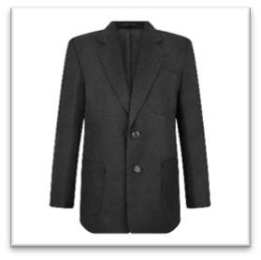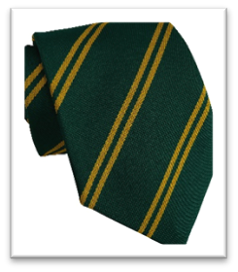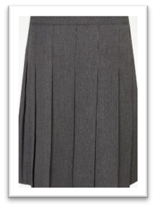

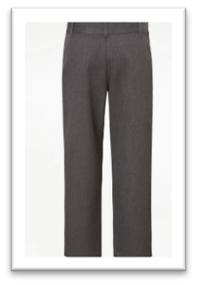

**PE Kit**

The PE uniform is as follows:

* Plain White polo shirt [no logo]
* Black games shorts
* Black sports/football socks
* Black ¼ zip PE sweatshirt [optional]
* Black tracksuit bottoms or school PE pant/leggings with logo [optional]
* Trainers

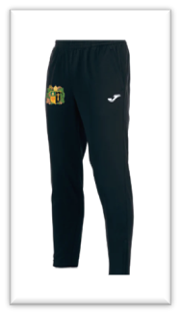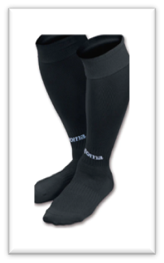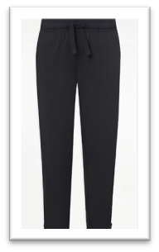

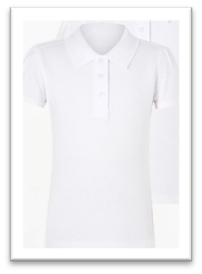

Pupils will complete a range of sporting activities throughout their time at St Wilfrid’s RC College. Within several of these activities it is recommended that pupils have safety equipment including shin pads for football and mouth guards for rugby.  Football boots are also recommended for any activity taking part on our school field in wet conditions. We would encourage the use these items within lessons.

**Equipment List**

It is essential that every pupil is provided with an appropriate bag for carrying exercise and textbooks to and from school. This ensures that books and equipment are kept in good condition.

All pupils must provide their own stationery equipment which must include:

* Black pen
* Green pen
* Pencil
* Rubber
* Ruler
* Scientific calculator

Pupils will be issued with a homework diary that they must bring to school each day. Families are asked to sign this weekly. It is also recommended that pupils bring a filled bottle of water with them. Only water is allowed to be consumed in lessons. Energy drinks are not allowed in school and will be confiscated.